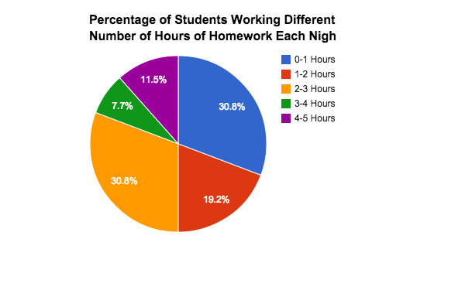
Research Question: How can we use homework as an instructional tool to support learning for students and teachers?
Methods:
Each teacher addressed a different aspect of homework completion and its impact on overall student achievement. In English, students were assigned an AP practice test (reading non-fiction pieces and answering multiple choice questions) and asked if he/she has ever used on line summaries in place of the assigned reading.

In Mathematics, homework assignments were created using different levels (2, 3, & 4) that matched the same formatting students would see on major unit assessments. At the end of each unit, student homework averages (graded on effort) were compared with student unit assessment grades. In addition, students were asked to analyze the class results themselves by creating a scatterplot of the data, and reflect on the relationship, if one existed.

In Social Studies, different class-based reward systems were implemented in an attempt to increase the completion and quality of homework turned in. In the first attempt, a class-wide goal of reaching a 100% completion/90% accuracy rate for the entire class was established. In the second attempt, the class-wide goal was modified to reaching an 83% completion/90% accuracy rate. Next, students compared unit homework grades to unit test grades and asked if there was a correlation. Lastly, a partner-based, class-wide goal of reaching 80% completion was developed in hopes of improving homework response rates.

In two study hall/learning center classes (27 students), a homework survey was administered consisting of 22 questions asking a variety of questions regarding the frequency, duration, quality, and motivation/reason for not completing homework. Examples of questions include, “How much time do you spend on homework each night?” and “What do you think is the reason for most homework?”

Sample Student Responses:
“I have stopped using Spark Notes and actually started reading.”
“I thought it helped to see how much you know in that section.”

Introduction:
Portsmouth High School is a suburban school with approximately 930 students. The student body consists of approximately 90% White, with the remaining 10% consisting of Black, Hispanic, Asian or Asian/Pacific, and American Indian. In regards to this particular study, approximately 130 students have been impacted, spread throughout seven classes and five teachers. The particular classes involved included one English class, one 9th grade World Geography class, two Algebra II classes, one Algebra I class, and two study hall/learning center classes. The research project spanned from October 2014 to March 2015. The primary topic of focus is homework, in particular, the factors affecting student motivation for homework completion and the effect of homework completion on overall student achievement.

Data:
In Mathematics, a moderate correlation (correlation coefficient=.77) between homework completion and improved unit test scores were identified (see “Unit 5 Data”). Specifically, by the end of a second unit, homework averages were a better predictor of test performance on the second unit test than they were on the first unit test.
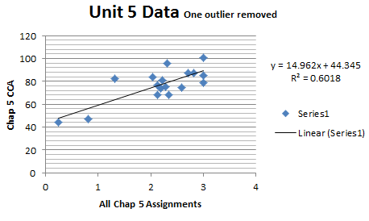
In English, after two AP practice tests, the percent of students using on line summaries dropped 15 percentage points from 57% to 42% and the failure rate fell precipitously from 57% in December to 2.7% or from 20 student failures to only one student failure. While there are a few students who still admit using on line summaries, more often students echo a response similar to “I improved my score from the first practice quiz. In my reading habits, I have not been relying on online resources as a back-up for after I read. Instead I have trying harder to interpret the text without reading a summary” or “I have stopped using Spark Notes and actually started reading.” After quantifying all 73 responses collected after both practice tests, a total of 40 indicate “a recognizable value for changing reading habits.”

In the study hall/learning center classes, survey responses revealed a majority of students do complete homework, even though students may report a variety of reasons for not having homework completed.

In the Social Studies class, a correlation between completing the study guide and improved test performance did not exist. Students performed equally well or not well independent of study guide completion.

Conclusion:
Homework is an important component of the learning process, and homework completion/accuracy appears to generally correlate with test performance. A strong link between homework and test performance, however, may be weakened when students’ perceptions and/or the assignments do not closely resemble test format/questions.
Students can also articulate a rationale for teachers assigning homework and classwork dedicated to delineating the relationship between effort at home and test performance indicates an overall increase in students effort in and performance of homework, and indirectly test performance. Further studies on additional methods for best demonstrating the connection between effort at home and improved academic performance is recommended.

Attempted Study Guide vs. Did Not Attempt
Study Guide | Test | Study Guide | Test
100 | 98 | 0 | 93
100 | 100 | 0 | 59
100 | 100 | 0 | 89
100 | 88 | 0 | 86
100 | 98 | 0 | 88
100 | 96 | 0 | 83
53 | 90
67 | 97
90 | 96 | 0 | 83
