**The Role of Self-Regulation in Improving Student**

**Academic Achievement in Mathematics**

Tracy Priestner

(Data contributed by Debbie Moniz-Phillips and Julie Simmons)

**Abstract**

This action research study investigated the role of self-regulation in improving student achievement. Research indicates that “self regulated learning is a desirable educational outcome that can be fostered by teachers who minimize academic competition, explain appropriate strategies, provide assistance during problem solving, and promote an atmosphere of collaboration in classrooms” (Paris & Newman, 1990). An analysis of student work was used to determine the effectiveness of four strategies to increase student self-regulation and in turn, improve academic achievement. These strategies include improving feedback and correcting common mathematical misconceptions via My Favorite No/Yes (Alcala, L.), utilizing mathematic vocabulary, creating a common rubric for grades one through three, and continuous practice with self reflection sheets across the curriculum. An analysis regarding the consistency between student reflections and teacher reflections of student work was conducted.

**Statement of the Problem**

How will having students engage in self-assessment impact their self-regulation in learning and achievement in mathematic thinking?

**Definition and Description of Terms**

**Self-regulated learning**

According to research, “definitions of students’ self-regulated learning involve three features: their use of self-regulated learning strategies, their responsiveness to self-oriented feedback about learning effectiveness, and their interdependent motivational processes. Self-regulated students select and use self-regulated learning strategies to achieve desired academic outcomes on the basis of feedback and learning effectiveness and skill (Zimmerman, 1990)

**Method**

The writers all utilized the “My Favorite No/Yes”. They designed an exit ticket, which features an application problem and a reflection task sheet. The writers utilized a four-step approach to improve the students’ academic achievement in mathematics. The first step was to utilize the My Favorite No/Yes. The second step was to create a chart of Common Core State Standards math vocabulary. The third step was to create a common rubric to be used at all 3 grade levels. The final step was to create a self-reflection sheet to be used across the curriculum on exit tickets, problem sets, or writing tasks.

**Subjects**

This action research study was conducted over the course of the 2014-2015 school year in a first grade, second grade, and third grade classroom in a suburban district in Tiverton, RI. At Pocasset School 15% of the students receive Special Education Services, 19% receive Title I Reading, and 16% receive Title I Math services. Additionally, 43% of the school population receives free/reduced lunch. The students in these three classrooms represent a range of learning needs (Special Education, Title I Reading, Title I Math, and behavioral concerns). All learners and their teachers in these three classrooms participated in the study. The purpose of the study was to have the students engage in self regulation to improve student achievement in mathematics.

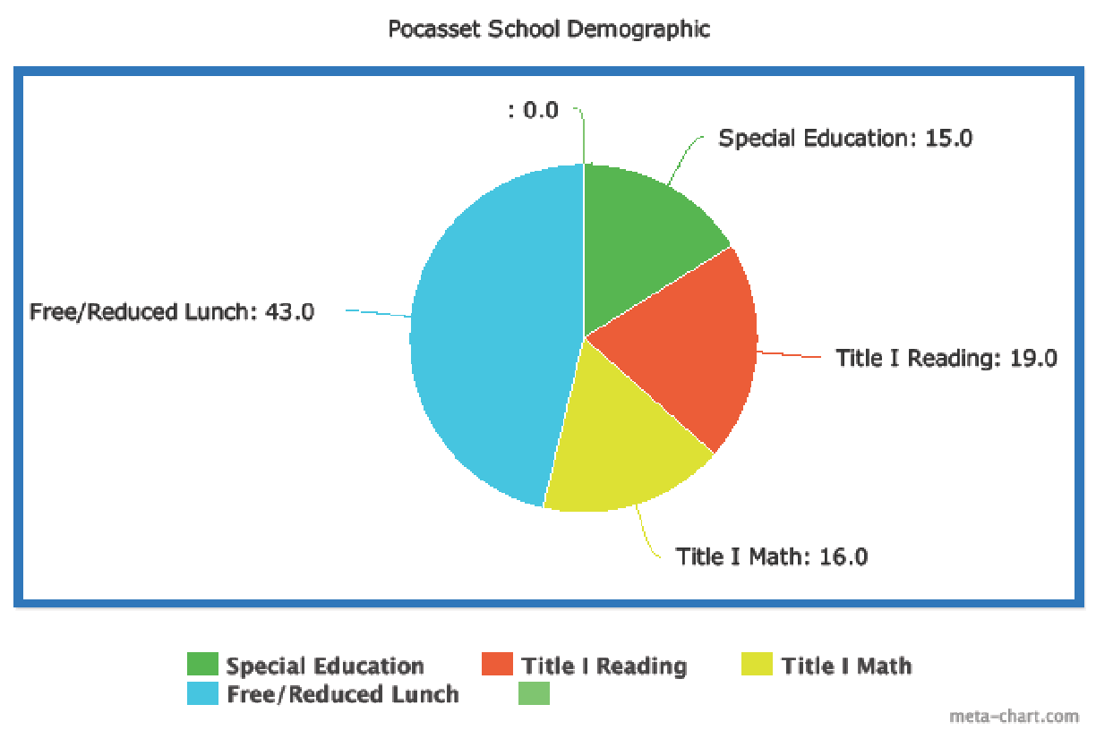

**Procedures**

**Procedures in the Collection of Data**

The writes instructed their respective classes a mathematics lesson from Eureka (Engage New York). The lessons began with an application problem, fluency practice, concept development with direct instruction, problem set to practice the skill of the lesson, student debrief, and an exit ticket to assess student learning and comprehension of the lesson. The writers distributed the exit ticket and students completed them independently. Upon completion of the exit ticket, each student evaluated himself/herself on his or her understanding of the concept. There were 3 ratings used: thumbs up to indicate understanding, a fist to indicate partial understanding of the concept, and thumbs down to indicate a lack of understanding of the concept and to signify that addition instruction is required. In addition, on the reverse side of the exit ticket sheet, students were asked to identify the skill that they were strong in and the skill area with which they require additional practice. Finally, the students met with the teacher one-on-one for correction, discussion of their self-assessment, and a 3-minute conference with the teacher. The teacher corrects the ticket, looks for agreement between the student’s view of their level of understanding and the teacher’s opinion of the student’s level of understanding. In other words, the desired outcome would be a correlation between the viewpoints. The teacher and student would then generate a plan for moving on.

**Procedures in the Analysis of Data**

Responses for each exit ticket were analyzed for correlation between the student’s opinion regarding his/her level of understanding of the concept and the teacher’s opinion of the student’s level of understanding of the skills assessed by the exit ticket. Results were tabulated and arranged into 2 categories and are summarized in **Tables 1-9**. The categories are as follows: (a) agree and (b) disagree.

**Appendix A**

**Problem Solving Checklist**

Did you…

1. Circle, box, underline, cloud “key” ___

math vocabulary words?

1. Show your thinking using pictures, ­___

numbers, or words?

1. Explain your thinking? ­­ ___
2. Use math vocabulary? ­ ___
3. Write an equation? ­ ___
4. Check to see if your answer makes ___

sense?

**Appendix B**

**Math Problem Solving Rubric**

|  |  |
| --- | --- |
| 5 | Above Standard |
| 4 | * *Show* your thinking using pictures, numbers, or words * *Explain* your thinking * *Use* math vocabulary * *Write* an equation with the correct answer |
| 3 | Almost Meets Standard |
| 2 | Below Standard |
| 1 | Does Not Meet Standard |

**Appendix C**

Name ___________________________ Date ____________________ # ______

**3 Minute Conference Reflection Form**

Learning Target:

Standard:

**My Opinion**

My strengths are _____________________________________________

___________________________________________________________

___________________________________________________________

What I think I need to work on __________________________________

___________________________________________________________

___________________________________________________________

**My Teacher’s Opinion**

My strengths are _____________________________________________

___________________________________________________________

___________________________________________________________

What I think I need to work on __________________________________

___________________________________________________________

___________________________________________________________

**My Plan**

C:\Users\tpriestner\AppData\Local\Microsoft\Windows\Temporary Internet Files\Content.IE5\YCCCSXDH\MC900211979[1].wmfWhat I will do now __________________________________________

___________________________________________________________

**Table 1 Grade 1: Baseline Exposure**

**Summary of Results of Student Reflection Sheet and Teacher Reflection of Student Work Sheet**

|  |  |  |
| --- | --- | --- |
| Student | Agree | Disagree |
| 1 | X |  |
| 2 |  | X |
| 3 | X |  |
| 4 | X |  |
|  |  |  |
| 6 | X |  |
| 7 | X |  |
| 8 | X |  |
| 9 | X |  |
| 10 | Absent |  |
| 11 | Absent |  |
| 12 | X |  |
| 13 |  | X |
| 14 |  | X |
| 15 | X |  |
| 16 |  | X |
|  |  |  |
| 18 |  | X |
| 19 |  | X |
| 20 | X |  |
| 21 | X |  |
| 22 |  |  |
| 23 |  |  |
| 24 |  |  |
| 25 |  |  |

65 % agreement between Student and Teacher Reflections of Student Work.

35 % disagreement between Student and Teacher Reflections of Student Work.

**Appendix D: Grade 1 Exit Ticket Baseline Exposure**

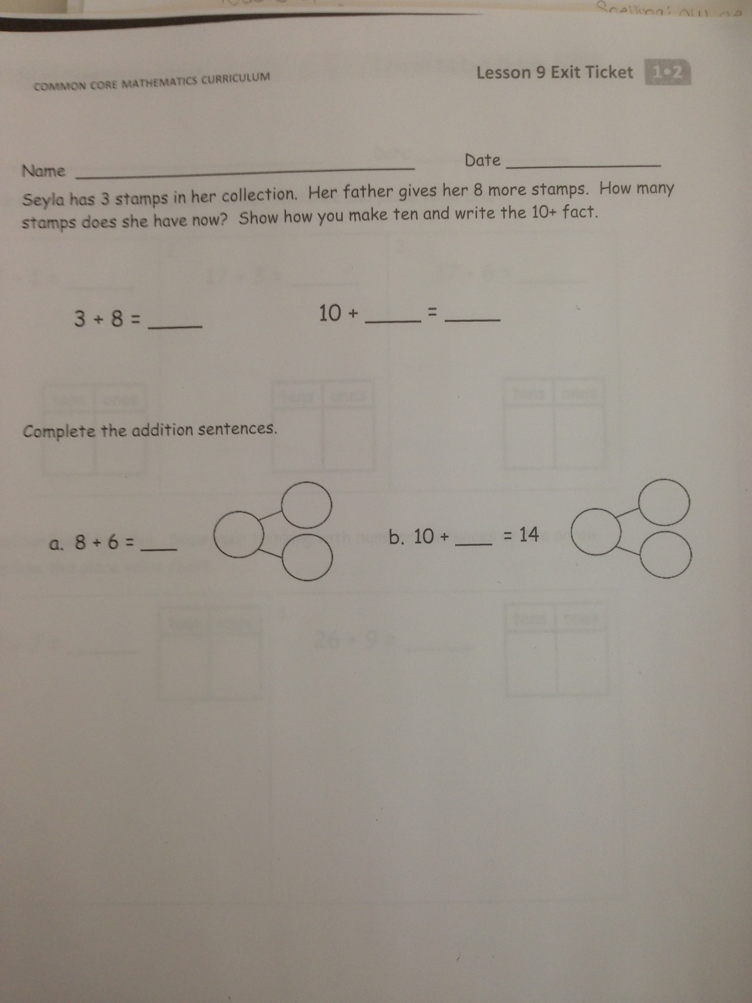

**Table 2 Grade 1: Second Exposure**

**Summary of Results of Student Reflection Sheet and Teacher Reflection of Student Work Sheet**

|  |  |  |
| --- | --- | --- |
| Student | Agree | Disagree |
| 1 |  | X |
| 2 | X |  |
| 3 |  | X |
| 4 |  | X |
|  |  |  |
| 6 | X |  |
| 7 | X |  |
| 8 |  | X |
| 9 | X |  |
| 10 |  | X |
| 11 |  | X |
| 12 | X |  |
| 13 | - | - |
| 14 |  | X |
| 15 | X |  |
| 16 | X |  |
|  |  |  |
| 18 |  | X |
| 19 | X |  |
| 20 |  | X |
| 21 |  | X |
|  |  |  |
|  |  |  |
|  |  |  |
|  |  |  |

44 % agreement between Student and Teacher Reflections of Student Work.

56 % disagreement between Student and Teacher Reflections of Student Work.

**Appendix E: Grade 1 Exit Ticket Second Exposure**

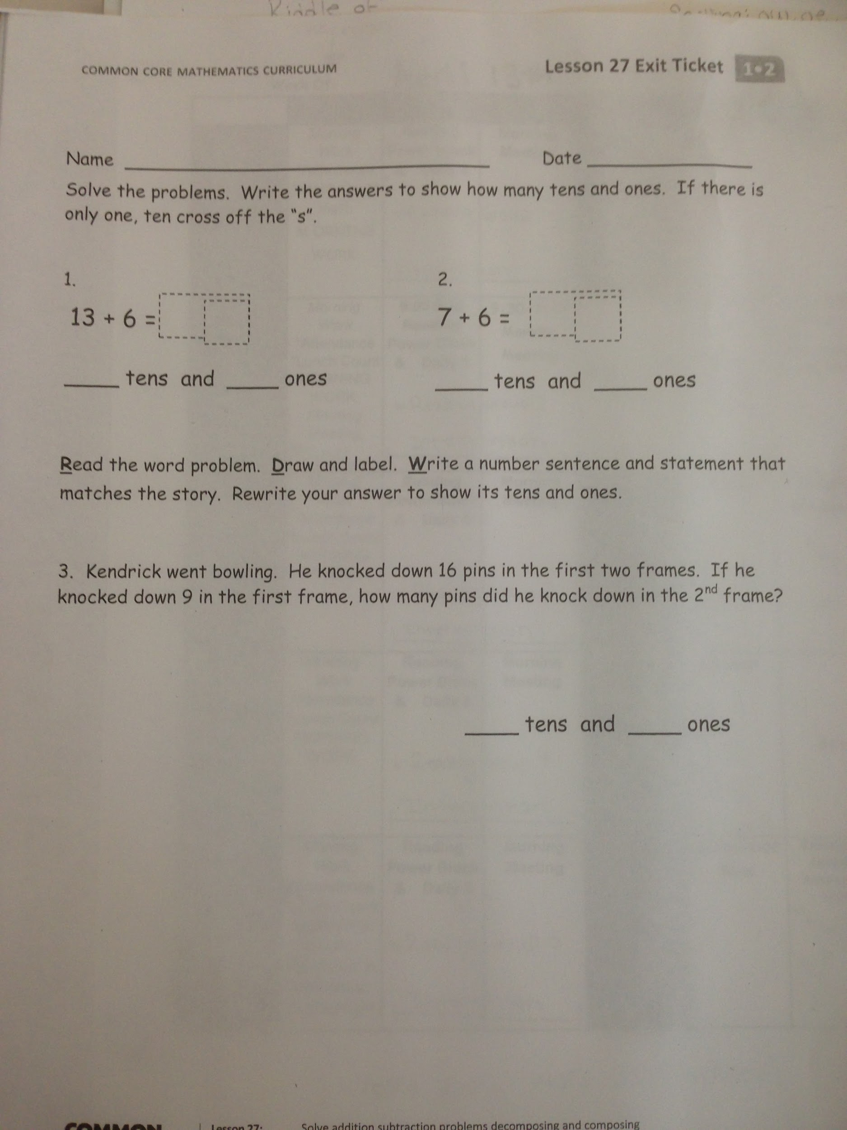

**Table 3 Grade 1: Third Exposure**

**Summary of Results of Student Reflection Sheet and Teacher Reflection of Student Work Sheet**

|  |  |  |
| --- | --- | --- |
| Student | Agree | Disagree |
| 1 | X |  |
| 2 | X |  |
| 3 | X |  |
| 4 | X |  |
|  |  |  |
| 6 | X |  |
| 7 | X |  |
| 8 | X |  |
| 9 |  | X |
| 10 |  | X |
| 11 | X |  |
| 12 | X |  |
| 13 | - | - |
| 14 | X |  |
| 15 |  | X |
| 16 | X |  |
|  |  |  |
| 18 |  | X |
| 19 | X |  |
| 20 | X |  |
| 21 | X |  |
|  |  |  |
|  |  |  |
|  |  |  |
|  |  |  |

78 % agreement between Student and Teacher Reflections of Student Work.

22 % disagreement between Student and Teacher Reflections of Student Work.

**Appendix F: Grade 1 Exit Ticket Third Exposure**

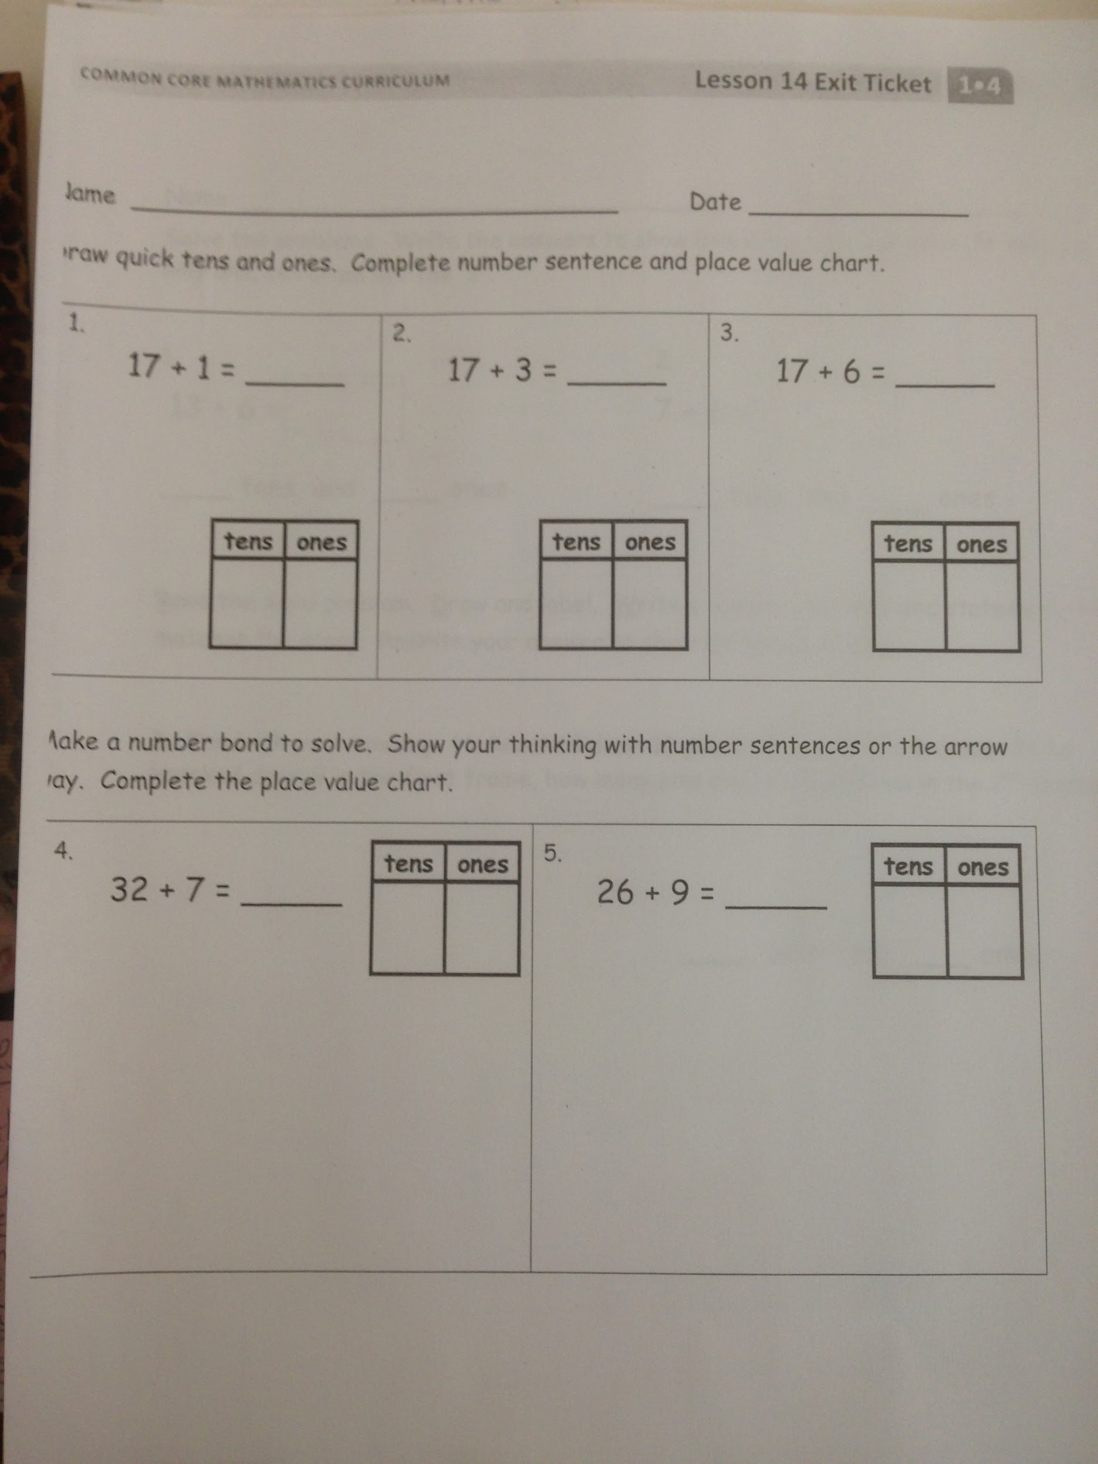

**Table 4 Grade 2: Baseline Exposure**

**Summary of Results of Student Reflection Sheet and Teacher Reflection of Student Work Sheet**

|  |  |  |
| --- | --- | --- |
| Student | Agree | Disagree |
| 1 | X |  |
| 2 |  | X |
| 3 |  | X |
| 4 | X |  |
| 5 | X |  |
| 6 | X |  |
| 7 | X |  |
| 8 | X |  |
| 9 | X |  |
| 10 |  | X |
| 11 | X |  |
| 12 |  | X |
| 13 |  | X |
| 14 |  | X |
| 15 | Absent |  |
| 16 | Absent |  |
| 17 |  | X |
| 18 |  | X |
| 19 | Absent |  |
| 20 | X |  |
|  |  |  |
|  |  |  |
|  |  |  |
|  |  |  |
|  |  |  |

53 % agreement between Student and Teacher Reflections of Student Work.

47 % disagreement between Student and Teacher Reflections of Student Work.

**Appendix G: Grade 2 Exit Ticket Baseline Exposure**

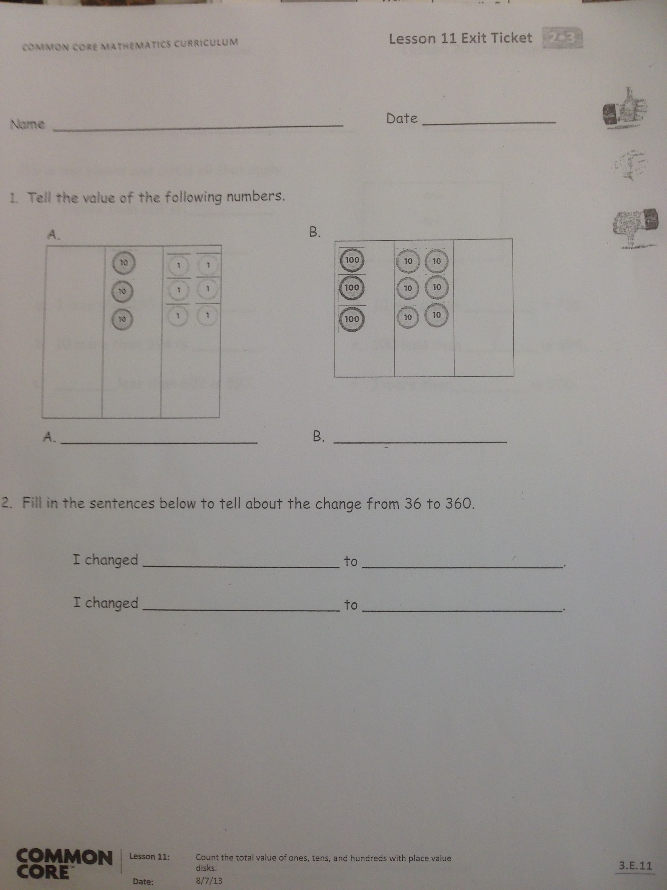

**Table 5 Grade 2: Second Exposure**

**Summary of Results of Student Reflection Sheet and Teacher Reflection of Student Work Sheet**

|  |  |  |
| --- | --- | --- |
| Student | Agree | Disagree |
| 1 |  | X |
| 2 |  | X |
| 3 |  | X |
| 4 | Absent |  |
| 5 | X |  |
| 6 | X |  |
| 7 | X |  |
| 8 | X |  |
| 9 |  | X |
| 10 |  | X |
| 11 | X |  |
| 12 |  | X |
| 13 |  | X |
| 14 | X |  |
| 15 | X |  |
| 16 |  | X |
| 17 | X |  |
| 18 |  | X |
| 19 |  | X |
| 20 | X |  |
|  |  |  |
|  |  |  |
|  |  |  |
|  |  |  |
|  |  |  |

47 % agreement between Student and Teacher Reflections of Student Work.

53 % disagreement between Student and Teacher Reflections of Student Work.

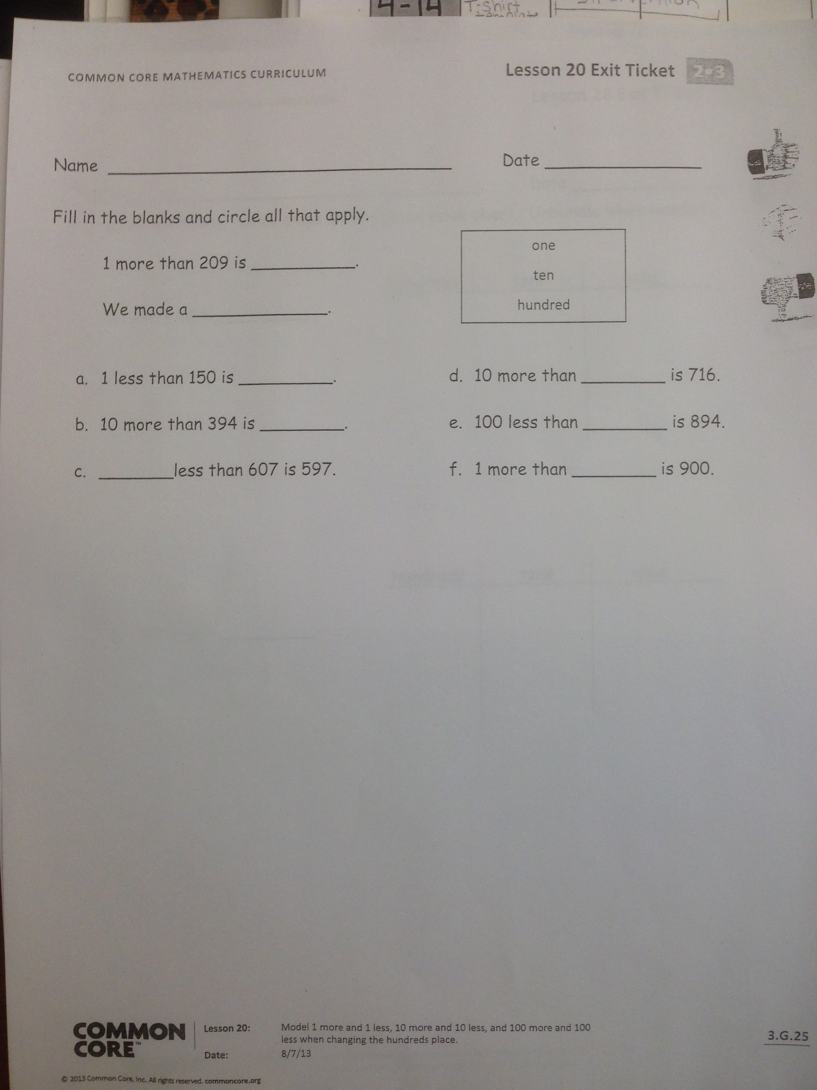**Appendix H: Grade 2 Exit Ticket Second Exposure**

**Table 6 Grade 2: Third Exposure**

**Summary of Results of Student Reflection Sheet and Teacher Reflection of Student Work Sheet**

|  |  |  |
| --- | --- | --- |
| Student | Agree | Disagree |
| 1 | X |  |
| 2 |  | X |
| 3 | X |  |
| 4 | X |  |
| 5 | X |  |
| 6 | X |  |
| 7 | - | - |
| 8 |  | X |
| 9 |  | X |
| 10 | X |  |
| 11 |  | X |
| 12 | X |  |
| 13 | X |  |
| 14 | - | - |
| 15 | - | - |
| 16 |  | X |
| 17 |  | X |
| 18 | X |  |
| 19 |  | X |
| 20 | X |  |
|  |  |  |
|  |  |  |
|  |  |  |
|  |  |  |
|  |  |  |

59 % agreement between Student and Teacher Reflections of Student Work.

41 % disagreement between Student and Teacher Reflections of Student Work.

**Appendix I: Grade 2 Exit Ticket Third Exposure**

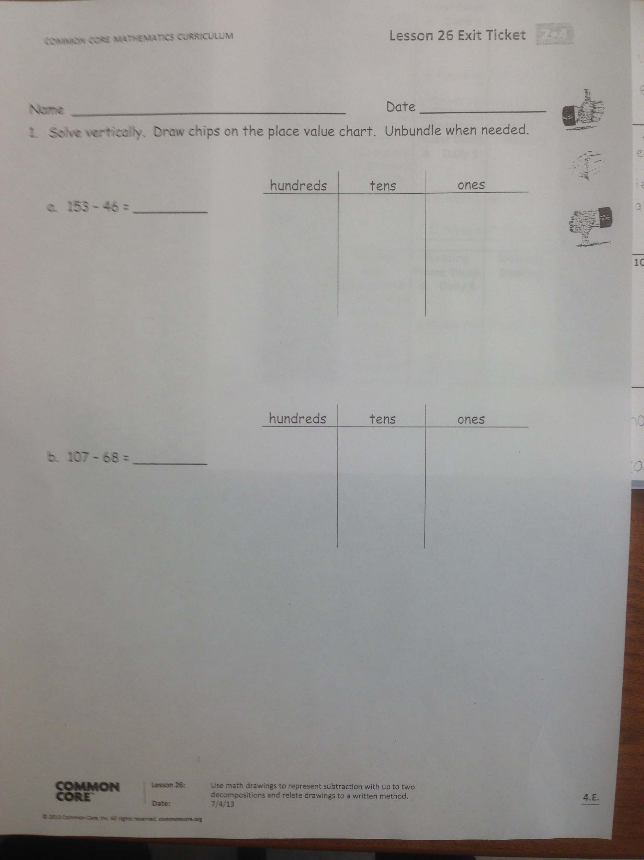

**Table 7 Grade 3: Baseline Exposure**

**Summary of Results of Student Reflection Sheet and Teacher Reflection of Student Work Sheet**

|  |  |  |
| --- | --- | --- |
| Student | Agree | Disagree |
| 1 | X |  |
| 2 |  | X |
| 3 |  | X |
| 4 | X |  |
| 5 | X |  |
| 6 | Absent |  |
| 7 | X |  |
| 8 |  | X |
| 9 | X |  |
| 10 | X |  |
| 11 |  | X |
| 12 |  | X |
| 13 |  | X |
| 14 | X |  |
| 15 | X |  |
| 16 |  | X |
| 17 | X |  |
| 18 | X |  |
| 19 |  | X |
| 20 | X |  |
| 21 | X |  |
| 22 |  | X |
| 23 | X |  |
|  |  |  |
|  |  |  |

59 % agreement between Student and Teacher Reflections of Student Work.

41 % disagreement between Student and Teacher Reflections of Student Work.

**Appendix J: Grade 3 Exit Ticket Baseline Exposure**

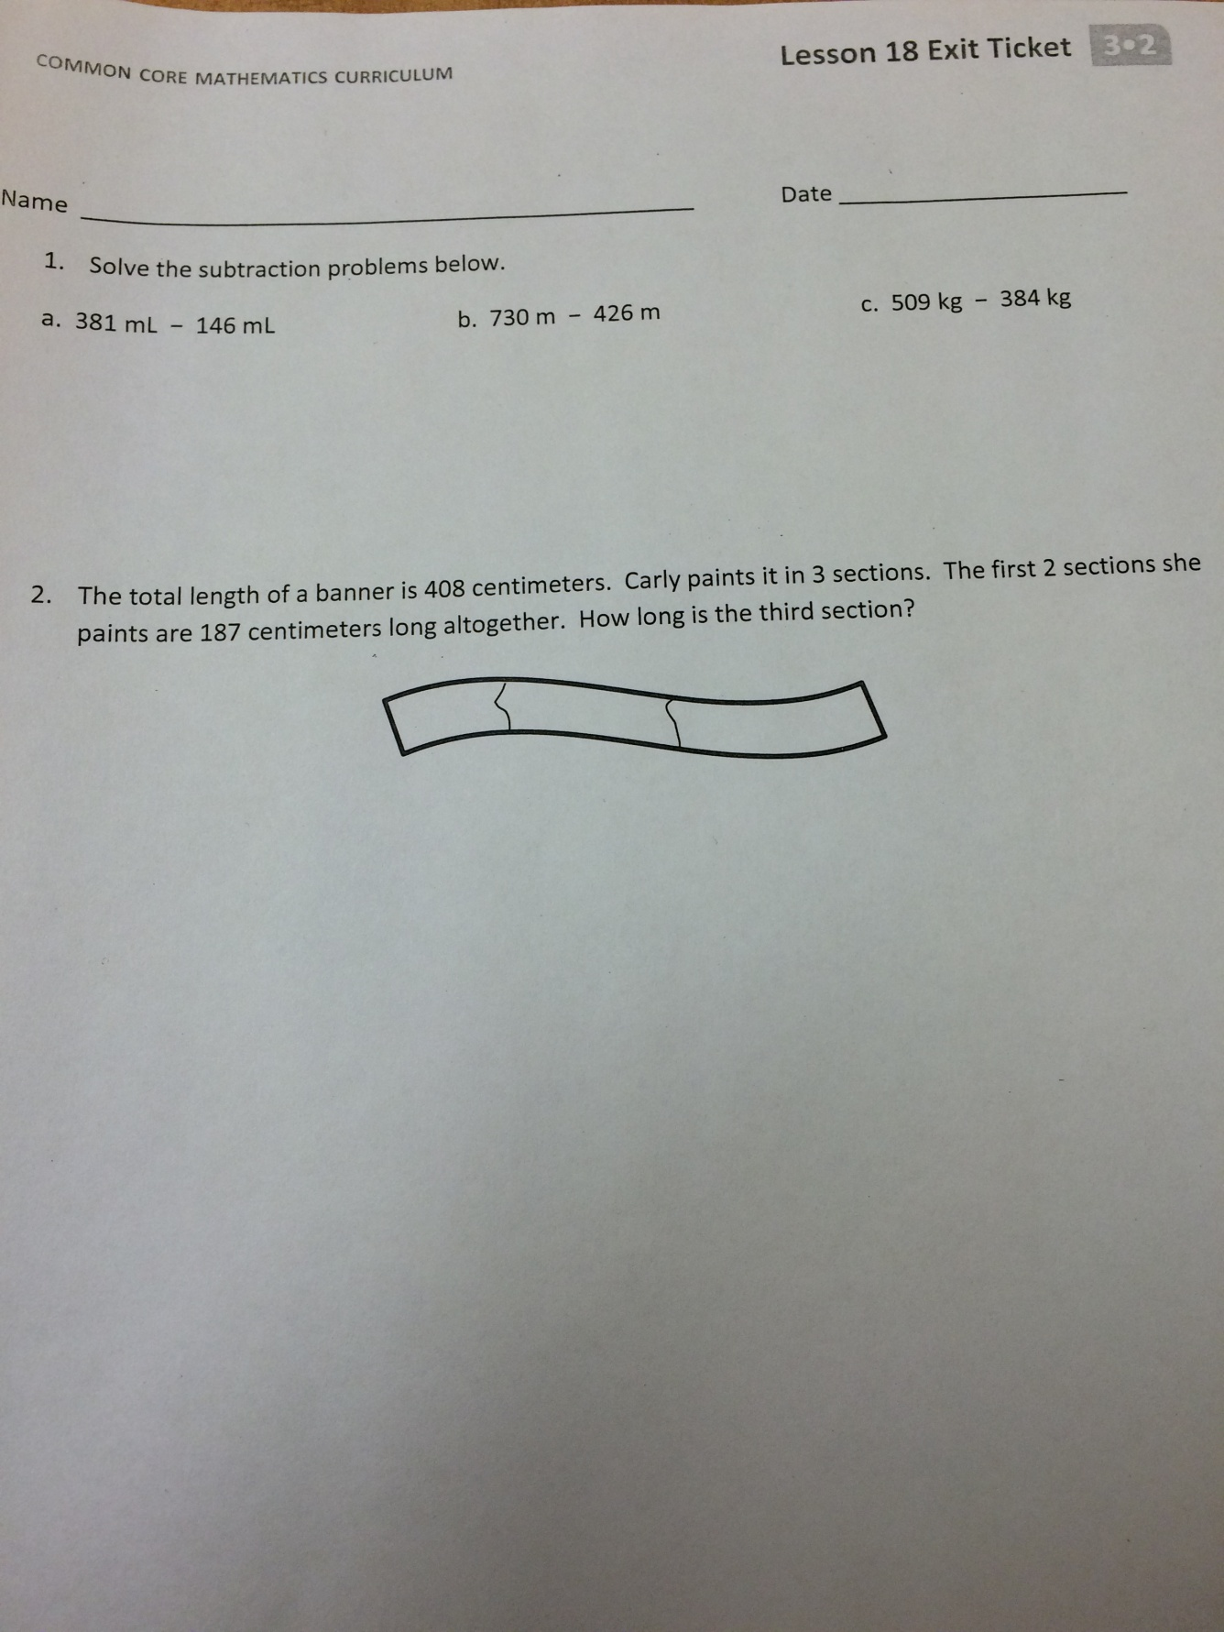

**Table 8 Grade 3 Second Exposure**

**Summary of Results of Student Reflection Sheet and Teacher Reflection of Student Work Sheet**

|  |  |  |
| --- | --- | --- |
| Student | Agree | Disagree |
| 1 |  | X |
| 2 | X |  |
| 3 |  | X |
| 4 | X |  |
| 5 | X |  |
| 6 | X |  |
| 7 | X |  |
| 8 |  | X |
| 9 | X |  |
| 10 | X |  |
| 11 | X |  |
| 12 | X |  |
| 13 | X |  |
| 14 | X |  |
| 15 |  | X |
| 16 | X |  |
| 17 | X |  |
| 18 |  | X |
| 19 | X |  |
| 20 | X |  |
| 21 |  | X |
| 22 | X |  |
| 23 | X |  |
|  | X |  |
|  | X |  |

76 % agreement between Student and Teacher Reflections of Student Work.

24 % disagreement between Student and Teacher Reflections of Student Work.

**Appendix K: Grade 3 Exit Ticket Second Exposure**



**Table 9 Grade 3: Third Exposure**

**Summary of Results of Student Reflection Sheet and Teacher Reflection of Student Work Sheet**

|  |  |  |
| --- | --- | --- |
| Student | Agree | Disagree |
| 1 | X |  |
| 2 | X |  |
| 3 | X |  |
| 4 |  | X |
| 5 | X |  |
| 6 | X |  |
| 7 |  | X |
| 8 | X |  |
| 9 | X |  |
| 10 | X |  |
| 11 | - | - |
| 12 | X |  |
| 13 | - | - |
| 14 | X |  |
| 15 | X |  |
| 16 | X |  |
| 17 |  |  |
| 18 | X |  |
| 19 | X |  |
| 20 | - | - |
| 21 | X |  |
| 22 | X |  |
| 23 | X |  |
|  |  |  |
|  |  |  |

89% agreement between Student and Teacher Reflections of Student Work.

11% disagreement between Student and Teacher Reflections of Student Work.

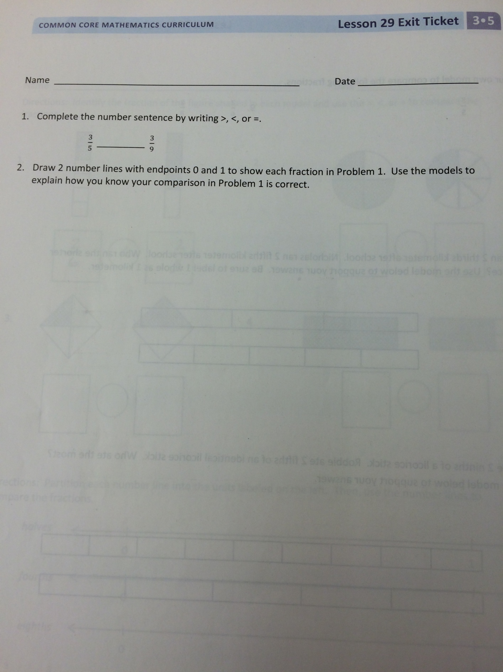**Appendix L: Grade 3 Exit Ticket Third Exposure**

**Results**

An analysis of the baseline Exit Ticket 1 table from grade 1 there was a 65% agreement and 35% disagreement between the Student and Teacher Reflections of student work. The table from the second exposure from grade 1 features a 45% agreement and 56% disagreement between the Student and Teacher Reflections of student work. The table from the third exposure features a 78% agreement and a 22% disagreement.

An analysis of the baseline Exit Ticket 1 table from grade 2 there was a 53% agreement and 47% disagreement between the Student and Teacher Reflections of student work. The table from the second exposure from grade 1 features a 47% agreement and 53% disagreement between the Student and Teacher Reflections of student work. The table from the third exposure features a 59% agreement and a 41% disagreement.

An analysis of the baseline Exit Ticket 1 table from grade 3 there was a 59% agreement and 41% disagreement between the Student and Teacher Reflections of student work. The table from the second exposure from grade 1 features a 76% agreement and 24% disagreement between the Student and Teacher Reflections of student work. The table from the third exposure features an 89% agreement and an 11% disagreement.

**Summary**

Students in grades grade one, two, and three engaged in self-assessment after a math lesson and following the completion of an exit ticket. This routine was followed for the duration of the year.

In first grade, the second exposure showed a decrease in the percentage of agreement between the student’s self-reflection and the teacher’s reflection of the student’s work. However, by the end of the year, there was a 78% agreement rate. This is an increase of 13% from the beginning of the year and a 34% increase from the second exposure.

In second grade, the second exposure showed a decrease in the percentage of agreement between the student’s self-reflection and the teacher’s reflection f the student’s work. However, by the end of the year, there was a 59% agreement rate. This is an increase of 6% from the beginning of the year and a 12% increase from the second exposure.

In contrast, the result from third grade shows a continued improvement throughout the year. The first exposure had a 59% agreement between the student’s self-reflection and the teacher reflection of the student’s work. The second exposure featured a 76% agreement between the student’s self-reflection and the teacher’s reflection of the student’s work. By the end of the year, there was an 89% agreement between the reflections.

Self-reflection by students takes time and practice to perfect. It is a valuable tool but success requires patience to develop. It is refreshing and time-saving for a student to be able to vocalize his or her strengths and conversely to be able to articulate accurately the skills upon which he/she need to improve. Through this study, students successfully became cognizant of their own needs and in turn took charge of their learning. Teaching time was maximized.

**Conclusions**

The writers were fascinated and enthralled with the Assessment Literacy Workshops conducted by Cassandra Erkens. These seminars invigorated our teaching. After each meeting we were eager to implement the different teaching techniques that were discussed, i.e. Data Notebooks, error analysis, My Favorite No, and 3 Minute Conferences. Through these workshops we were able to change our paradigm regarding assessment. The Assessment workshop series changed the dynamic in our classroom. Our roles and the roles of our students have changed. We are now facilitators rather than directors. Our students are now self-directed and have more ownership of their learning and of their goals. There has been a movement toward child-centered learning. Our expectations of our students have risen across each grade level. Students in grades 1-3 now maintain their own learning goals, select their own learning goals, and track their own progress.

We have shared our Assessment Literacy knowledge with our colleagues. We presented a PowerPoint at a faculty meeting and as a result, several of our colleagues are now utilizing Data Notebooks in their classrooms as well as error analysis through the use of My Favorite No.

**Discussion**

The writers are so grateful to have had the opportunity o work with Cassandra Erkens to expand their knowledge and understanding of assessments.

First, further analysis of the data revealed that the more the students used self-assessment and the “thumbs Up- Fist-Thumbs Down” part of the exit ticket, the more accurate they became.

Second, the more practice the students had with completing the 3 Minute Conference forms, the quicker and more articulate they were.

Third, additional practice with the Thumbs up-Fist-Thumbs Down” lead to an increased ability to use the 2 tools to set personal learning goals and to guide learning.

Fourth, it is extremely helpful to set a timer when conducting 3 Minute Conferences. They are also an efficient way to meet individually with students and to conference with them.

Fifth, the writers also learned that both the 3 minute Conference and self-assessment can be used effectively in other academic areas.

Sixth, the writers also found My Favorite No to be a powerful tool for error analysis. It has become a staple of their math instruction.

In closing, the data that was collected by the three teachers at the three different grade levels does support our hypothesis. Having students engage in self-assessment does impact their self-regulation in learning and achievement in mathematic thinking.

**References**

Alcala, L. (2012). My Favorite No: Learning From Mistakes, (video file). Retrieved from

[www.teachingchannel.org/videos/class-warm-up-routine](http://www.teachingchannel.org/videos/class-warm-up-routine).

Paris, S. & Newman, R. (1990). Developmental aspects of self-regulated learning. *Educational*

*Psychologist, 25*(1), 87-102

Zimmerman, B.J. (1990). Self-regulated learning and academic achievement. *Educational*

*Psychologist, 25*(1), 3-17.