Action Research Project
Using Formative Assessment to Improve TK Student Writing
Ceres CA

During the 2019-2020 school year, two TK teachers in Ceres California (one from Don Pedro Elementary and one from Walter White Elementary) joined together to engage in an action research project that aimed to improve student writing using quality formative assessment practices. Specifically, the team wanted to answer the question: how can we employ quality formative assessment practices that will improve student writing at the TK level?

What is Transitional Kindergarten (TK)?
To clarify, TK is a grade level created by the State of California for students turning 5 between the months of September through December. Prior to the creation of TK, these students were considered kindergarten students. The State of California had changed the kindergarten age to be students turning 5 after December of each year and in that process added an additional grade level to the elementary school grade range. The following quick guide can lend additional clarity about the TK program:
https://edsource.org/2017/understanding-transitional-kindergarten-a-quick-guide/585073

To answer their question with their specific student population, the team engaged in many formative writing opportunities such as free flow journals, directed journals, shadow writing, and sight word sentence writing. They also added the formative assessment practices of 1) clarifying criteria for writing, 2) co-constructing a progression of writing with in-class exemplars and clarifying stage descriptors, and 3) engaging students in self-assessment and goal setting. The team met often, even though their efforts spanned two locations and their time was voluntary. They were focused on their results and used evidence from each other’s classrooms to make key modifications along the way like adding Directed Art to teach details and moving the sequence of their writing opportunities.

The pandemic upended the end of the school year and disrupted some of the early results. However, the team persisted, re-engaging in the same work to improve student writing during the 2021-22 school year. The formative assessment practices of 1) clarifying criteria for writing, 2) co-constructing a progression of writing with in-class examples and clarifying stage descriptors, and 3) engaging students in self-assessment and goal setting, were instrumental in getting students back on pace more quickly. The overall impact of the pandemic slowed their initial start to the work in 2020 and 2021, but the 3 formative processes that the team employed were helpful to moving students more quickly on the writing continuum because they had a firm foundation on which to launch. Between 2019 and 2022, then, the team found considerable gains in student development, interest, and motivation to improve their writing capabilities.

To begin, the research was initially conducted during the 2019-20 school year in Ceres CA and continued through the 2021 – 22 school year. The following charts provide the context for the schools and the student population involved in their efforts:
Student Population for Don Pedro Elementary, Ceres USD California
Grades TK-K-1-2-3-4-5-6

2019 – 2020, 549 Students |  |  | 2021 – 2022, 480 Students
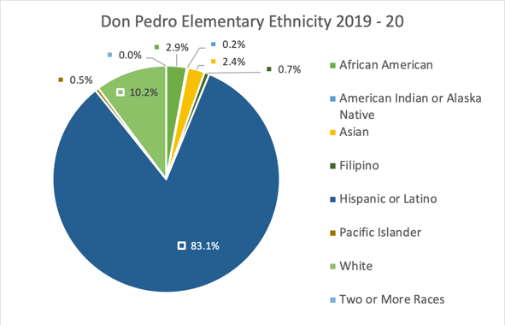 |  |  | 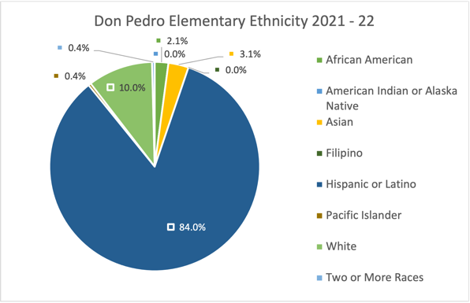
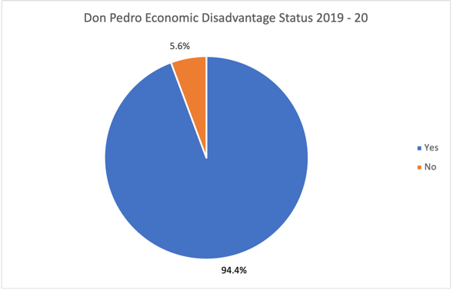 |  |  | 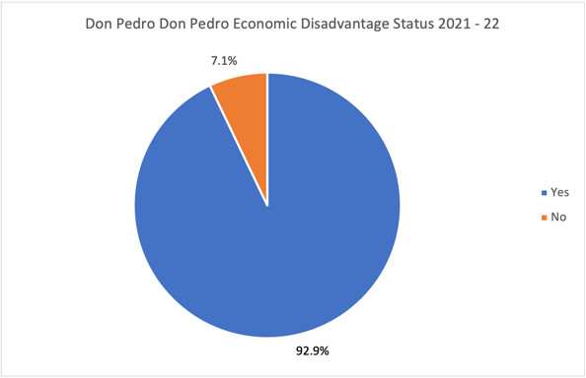
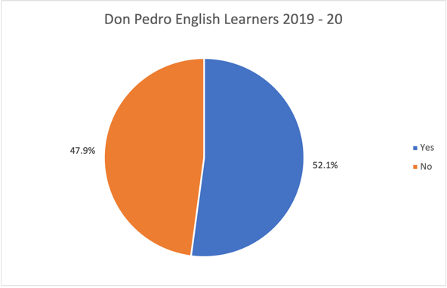 |  |  | 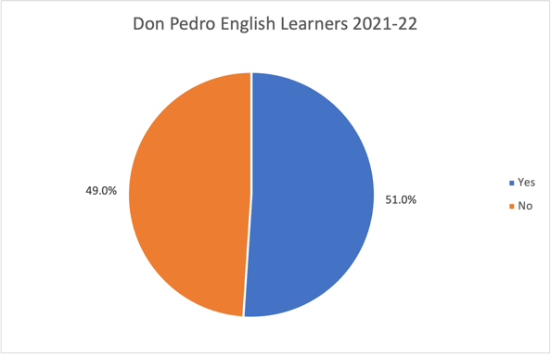
TK Demographics
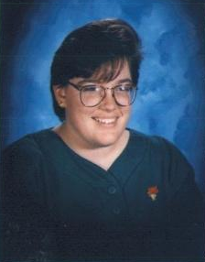 | Teresa C Diamond is a TK teacher at Don Pedro School in Ceres Unified School District. She started as a Preschool teacher (PK-2 years), moved on to Kindergarten (K-19 years) and currently teaches Transitional Kindergarten (TK-8 years). She loves teaching young children and enjoys watching as they grow and experience new skills that challenge their young minds. |  | 2019-2020 | Total TK = 24 students  - Asian=1 student  - Hispanic=21 students  - White=2 students
 |  |  | 2020-2021 | Total TK = 23 students  - Hispanic=19 students  - White=3 students  - Two or More Races=1
 |  |  | 2021-2022 | Total TK = 20 students  - Hispanic=16 students  - White=4 students
Student Population for Walter White Elementary, Ceres USD California
Grades TK-K-1-2-3-4-5-6

2019 – 2020, 524 Students |  |  | 2021 – 2022, 390 Students
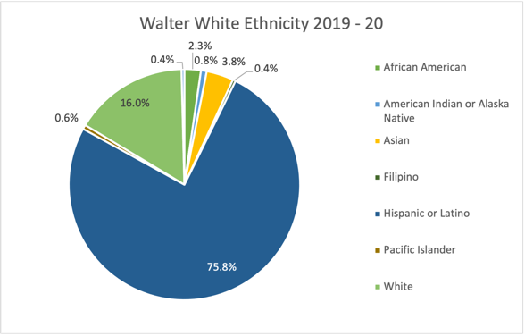 |  |  | 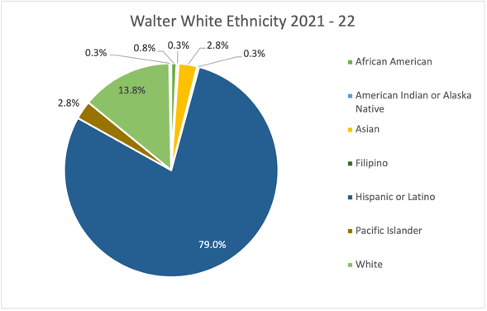
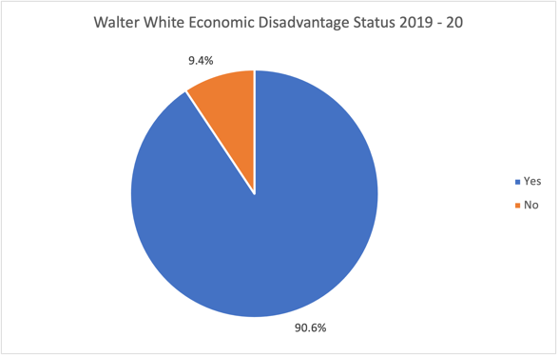 |  |  | 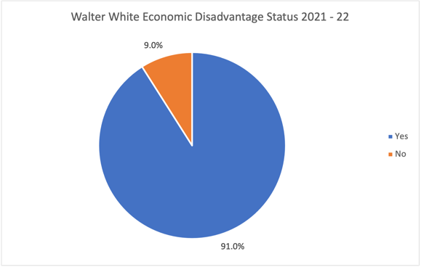
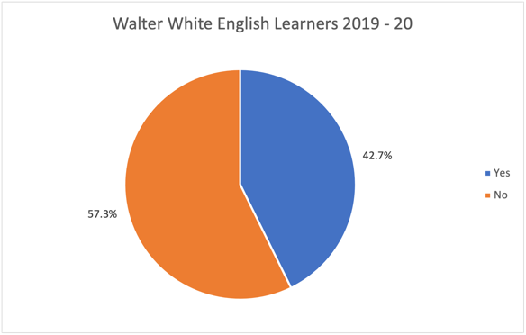 |  |  | 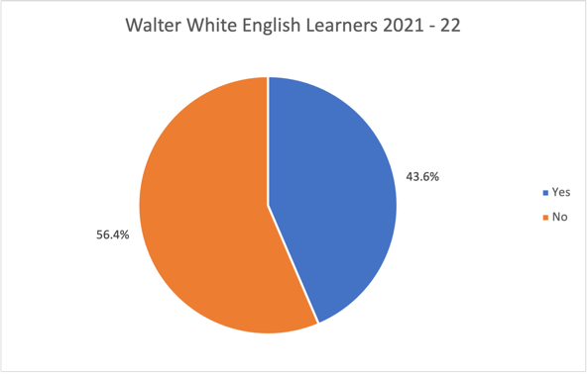
TK Demographics
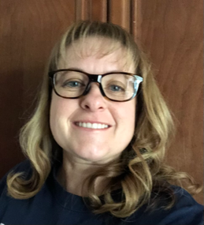 | Amy I Stubblefield is a Transitional Kindergarten teacher at Walter White Elementary school in Ceres, Ca. She received a Child Development Degree from California State University Stanislaus. She has taught four years of preschool and is currently in her eighth year of teaching Transitional Kindergarten. She feels it is important to foster young children’s learning experiences while giving them the confidence to do things that they may otherwise be afraid to do in a developmentally appropriate way. |  | 2019-2020 | Total TK= 41 Students  - Other Indian= 1 Student  - Other Asian= 1 Student  - Filipino= 1 Student  - Hispanic= 27 Students  - Black= 2 Students  - White= 8 Students  - Declined to State= 1 Student
 |  |  | 2020-2021 | Total TK= 26 Students  - Total TK= 13  - Hispanic= 13
 |  |  | 2021-2022 | Total TK- 21 Students  - American Indian or Alaskan Native= 1 Student  - Other Asian= 1 Student  - Hispanic= 19 Students

* All demographic data were accessed at https://dq.cde.ca.gov/dataquest/page2.asp?Level=School&Subject=Enrollment

Both elementary schools have only one teacher at the TK level. Teresa Diamond, the TK teacher at Don Pedro Elementary, and Amy Stubblefield, the TK teacher at Walter White Elementary worked across campuses to design, implement, and author of this action research project.

The team persisted in their action research project between 2019 and the spring of 2022, even through the pandemic. As they answered their primary action research question: how can we employ quality formative assessment practices that will improve student writing at the TK level?, they came to value a new way of engaging young learners in the writing process. The design outlining their efforts, their mid-progress alterations, and their key learning, final discoveries, and recommendations follow.

What did you try?

Instruction and Formative Assessment Strategies

First, we instituted and sequenced a series of formative writing opportunities. At the beginning of the year, we always expose our TK learners to many ways of strengthening fine motor skills. We know that to hold/control a pencil TK learners must have strong fine motor skills. For example, TK learners cut along lines, string beads, use Play Dough, create tear art, use tweezers to move small objects, and so on. We continue doing these activities throughout the year to ensure all TK learners get time to develop better fine motor skills to help grip and control a pencil for writing.

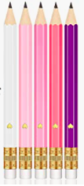
Beginning in 2019, we started using only small golf pencils (shorter and thicker than a regular pencil) when writing. TK learners seem to have better control over a smaller pencil at this young age.

In 2019, our first experience with writing was a free-flow journal. TK learners were given a journal and told to turn to the next page and draw/write about anything of their choice, letting them experiment with writing. TK learners could draw or write whatever they desired with no help from an adult. We met with our TK learners after they completed the journal entry and asked them to talk about (dictate) their story. At Don Pedro, the students were given blank pages and at Walter White students were given a lined notebook to begin.

Figure 1: Example of small golf pencils

TK learners were allowed to experiment with free flow journaling approximately three times before we moved on to direct journaling. In the new journals, TK learners were given a specific topic and were directed to write about that topic. For example, we would say, “Today you are going to write about your favorite food.” Then, as a class, we would brainstorm, making a list or chart to post in the room. Often, we tried to include visuals, like drawing different foods and labeling those foods. After a whole group discussion, TK learners were put into small groups with an adult (classroom paraprofessionals or other volunteer aids) and asked to start writing about the topic on their own. Once TK learners are done drawing/coloring their pictures (and possibly labeling things within the picture), we asked each learner to give the teacher a complete sentence (dictate) about the drawing.

Figure 2: Two samples of early student writing with teacher transcriptions.

An example of early free flow journaling. Note: students are not expected add words or letters at this point. |  | An example of early free flow journaling with dictation. Note: Some students attempt writing. An adult writes the words the student uses when describing their drawing.
 |  | 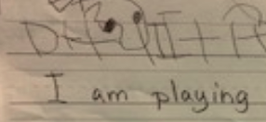

The TK students were told they could write about anything. In the provided examples, the two students wrote about their family. They drew the picture and then they dictated the story to an adult who transcribed for them. Once they learned how to draw a person, making pictures with their family in them became a favorite activity.

The next form of writing we tried was Shadow Writing. As a whole group we teach TK learners using a pocket chart how to use sight words to form a sentence. For example, I see the _______. We explain where to start writing (left hand side) spacing and ending punctuation. We also discuss the importance of the words matching the picture. Once we teach these skills as a whole class a few times, we then have TK learners in small groups with an adult and ask them to shadow/copy the same sentence, reminding them of our writing rules. Once TK learners write the sentence (shadow write) we ask them to draw a picture to match that sentence.

Figure 3: Examples of Shadow Writing

An example of early templates for shadow writing |  | A later example of shadow writing without the immediate prompt.
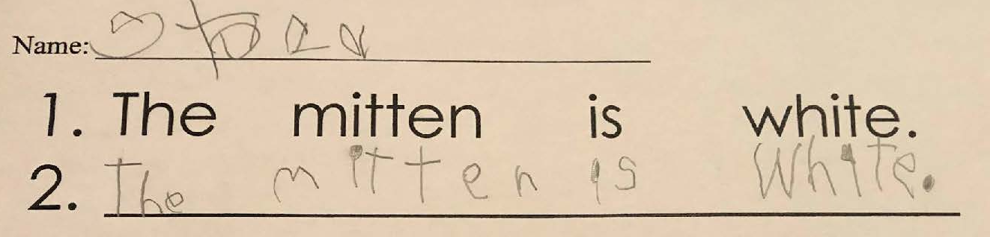 |  | 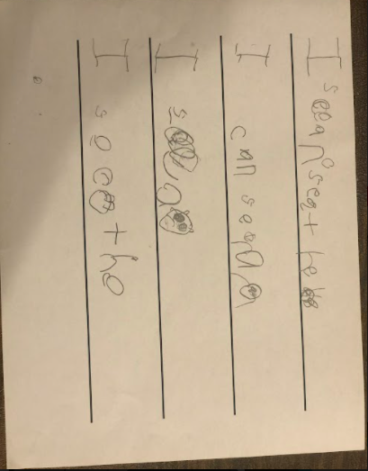

Note: In the later example, the student had a lot of writing anxiety at the beginning of the school year. At times she would cry with frustration and get upset. After using shadow writing a few times she became much more comfortable and eager to try things that might have felt challenging to her before.

Once learners understood the idea of writing, we moved into sight word writing. It’s always important to expose TK learners to writing sentences using familiar (sight) words. This is an ongoing best practice, so we always take time during our day throughout the entire year to review old and new sight words in a variety of ways so that TK learners are exposed to vocabulary often and can begin to recognize, understand, and use them with a high degree of frequency. For example, we read them, write them, stamp them, sing them (using songs by Heidi Butkus), play, find the sight word games, and kinesthetically create the words using Play Dough or Wikki Stix. While teaching TK learners sight word writing, we use a pocket chart, putting strips with our sight words on them into the pockets. Then, as a class, we pull and use those strips to create a sentence. For example, when we give the students a sentence frame such as “I see a _____,” we ask the students to pull and place the appropriate sight words into the provided blank space. Because sight word development is an important but introductory level proficiency for TK learners, we tell our students that they can leave a blank space for the word they desire but don’t know or they draw a picture of it in the words place.

Whenever we engage in Sight Word Writing, TK learners are allowed to go to their small groups to address a given theme or topic for their writing. TK learners begin writing, understanding that they can use sight words from the board or pocket chart to help them. Once they write the sentence, they are asked to draw a picture to match their sentence.

Next, we added formative processes that would help our learners better understand qualities of writing. Much of the writing described thus far, albeit formative in nature, was standard procedure for TK teachers. Our action research project took on a new formative assessment strategy beginning in the fall of 2019 and following the sight word writing process. We began teaching our TK learners about the quality criteria for writing and empowering them to make decisions about the quality of their own writing. In alignment with the research on promising practices in formative assessment (see Chappuis, 2012 and 2015; Erkens, Schimmer, and Dimich, 2017 and 2018; Wiliam, 2018; White, 2022 ), we believed it was important to build upon student successes using actual artifacts from the classroom. We used our large screen projector to project each TK learner’s piece of work to the whole class. As a whole class we discussed each piece and offered positive feedback on what we could see in each paper. As a class, we then decided what an early, or ‘beginning,’ writing piece might look like. We described the features and labeled those features ‘Stages 1.’ Then, we began to explore how we could improve our writing (moving it to the next level, or Stage 2) by adding different things, like more words or more details in our images. We also looked to see if any of the writings we had already reviewed would help us define stage 2 writing so we could use those pieces as exemplars. This protocol continued throughout the year, empowering learners to define ‘what comes next’ in quality writing so they could co-construct the quality criteria for each stage of development.

In each stage, we looked at all the writing done by TK learners and chose some pieces to be used as our checkpoint exemplars. In this way, we were able to create a visible writing continuum for TK learners to reference while writing. TK Learners were excited about co-constructing criteria for each stage and finding class examples that fit that stage because it was their or their peers’ writing. Immediately, we noticed a tremendous amount of class pride in the visible continuum and individual clarity in the criteria defining each stage.

Once each class at the different campuses identified the papers that would be used for our writer’s checkpoint, the two of us met and created a rubric using the preschool foundations and TK standards combined. The resulting rubric, which can and will still be refined over time, will be used for TK learners to assess their own work and push them forward in the writing process. Though we know the stages, we still intend to engage our learners in the protocol of co-constructing quality criteria and identifying exemplars because the process was so illuminating for our learners.

Figure 4: Classroom displays of the student created writing continuum

An example of a class generated rubric (in stages) for quality writing. |  | An example of student work and self scoring that includes their description of where they are now and where they want to go next with their writing.
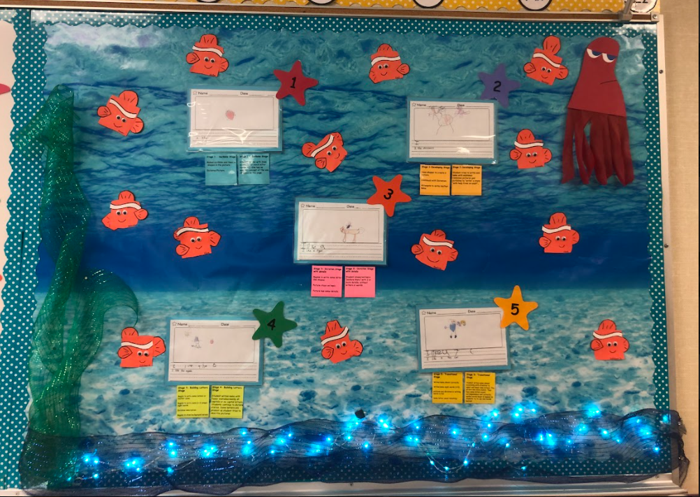 |  | 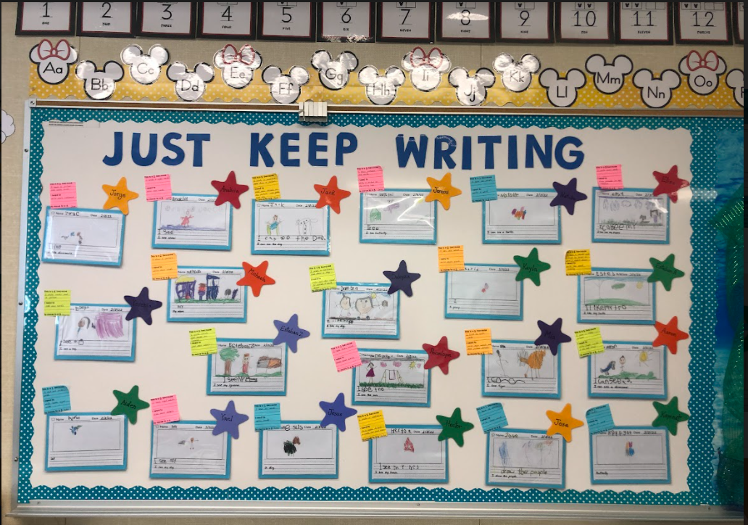

The sample on the left is the class generated rubric for quality writing. Though we already knew the criteria for the qualities we were seeking, we engaged students in examining the exemplars we had gathered and then had them describe the features they observed. We used their words in the board descriptors to increase their understanding and ownership of good writing. The exact levels of the rubric are spelled out in more detail in Figure 5. We came up with our interpretations of the phases in the continuum by exploring the preschool foundations books and the writing standards for Kindergarten for setting realistic expectations.

In the sample in the right, each student works to identify where he or she is in their current writing level, where they want to go next, and how they want to do that work. We transcribe their thoughts on Post It notes that are preprinted with the prompts and then post their work with their current self-assigned level (on the stars) and their improvement plans on the Post It notes. Students are not competitive or embarrassed; rather, they are excited and eager to share in the joy of each others’ progress.

Figure 5: Specific Rubric (or phase) Language

 |  | Sample of writing with phase descriptors on the wall display |  | Specific descriptors that go along with each phase
1 Phase one has some kind of drawing and dictation of what the student wanted to say. |  | 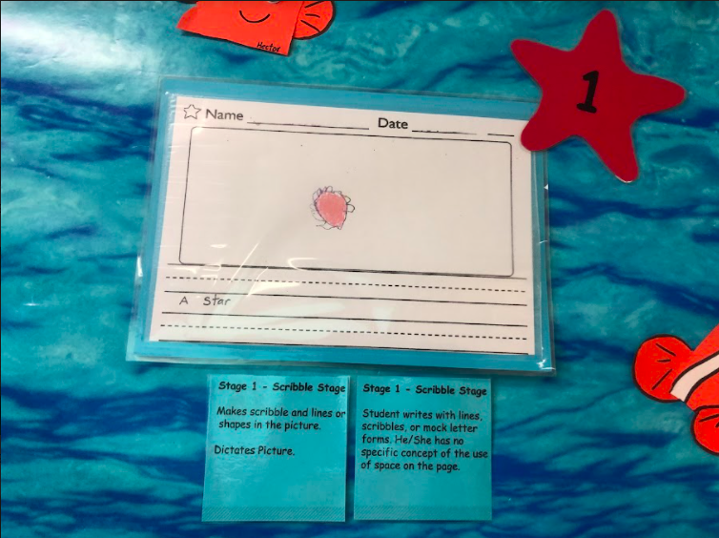 |  | 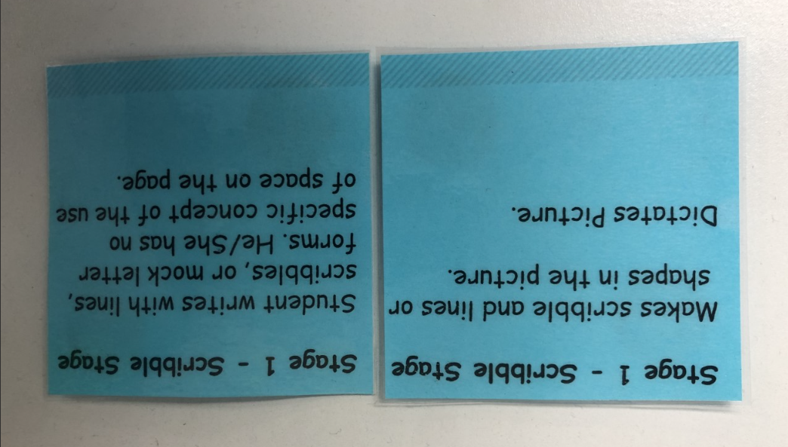
2 Phase two has pictures made from shapes and the students attempt to write words he or she knows. |  | 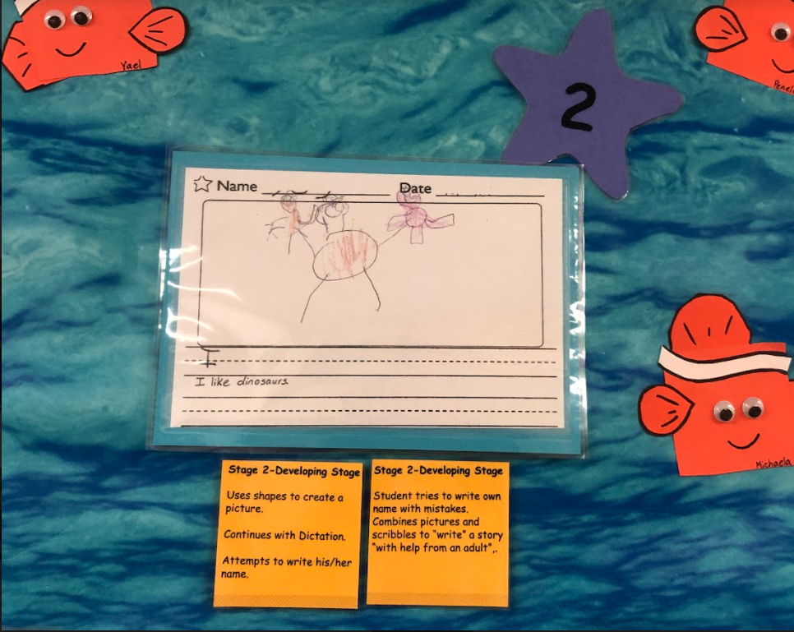 |  | 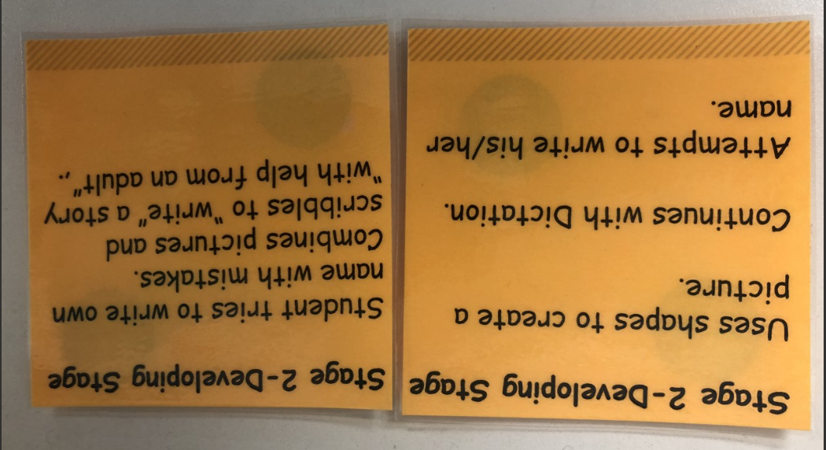
3 Phase three has pictures with added details. The students select a sentence and then base their picture on that sentence. This student also began writing words that they already knew. |  | 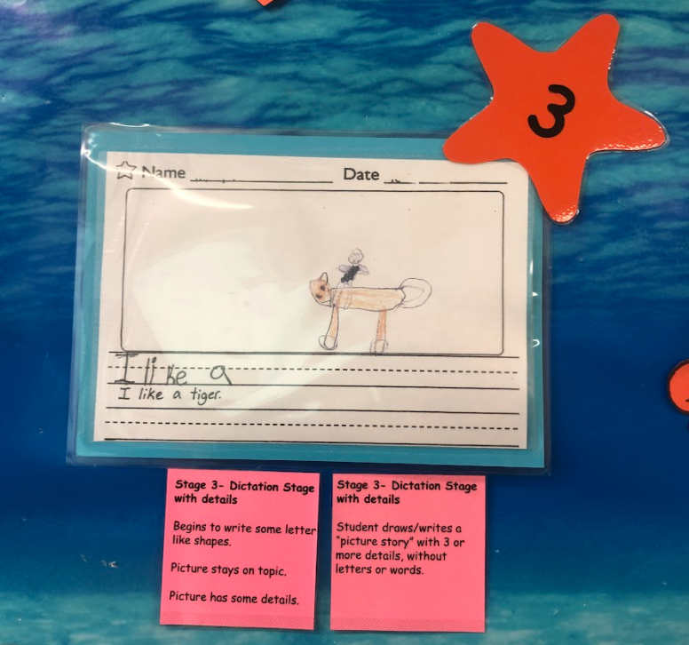 |  | 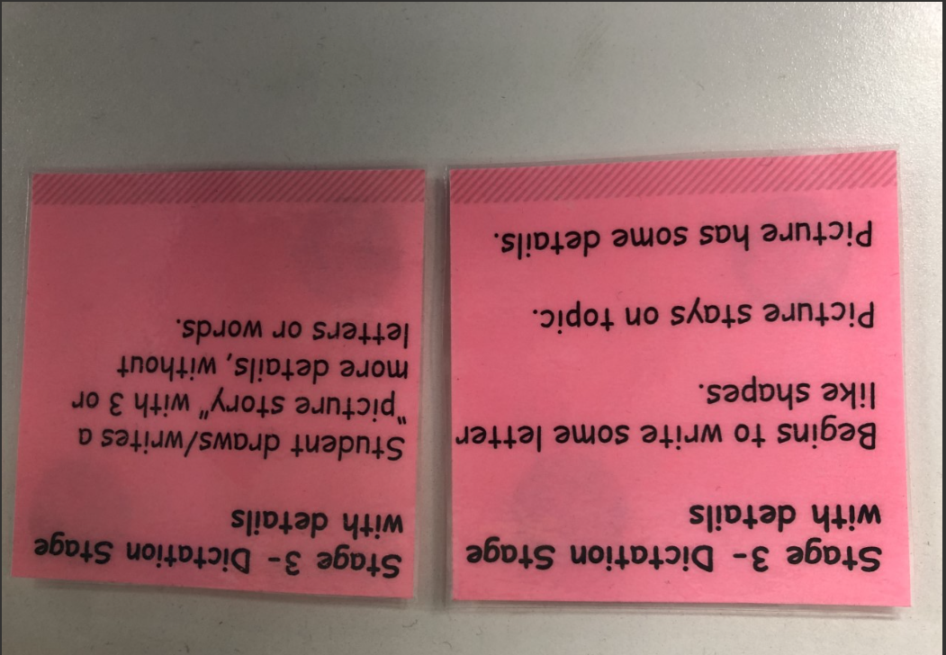
4 In phase four, students write known words and add a picture to express what they are trying to say. In this example, the student added more details like a sun and grass to show being outside. |  | 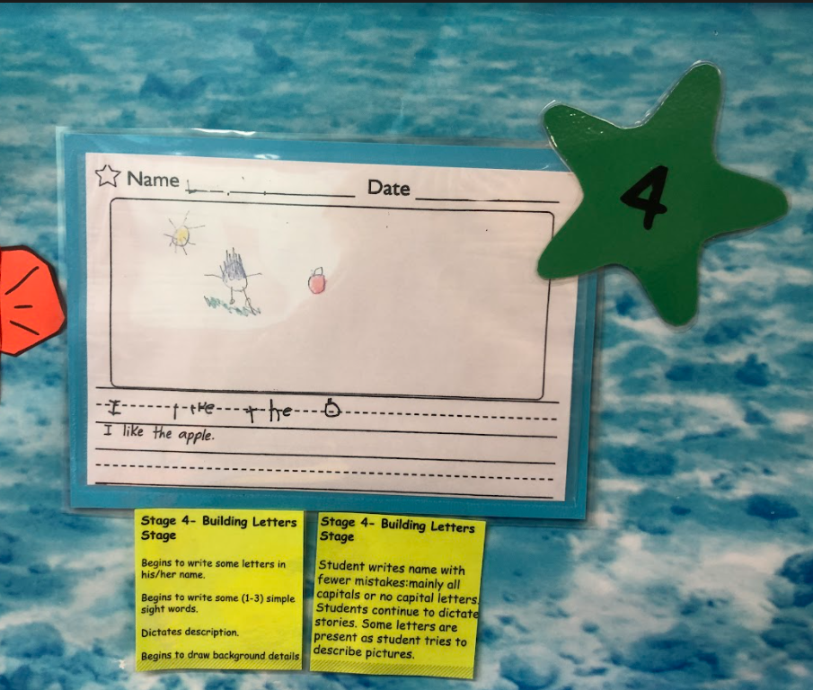 |  | 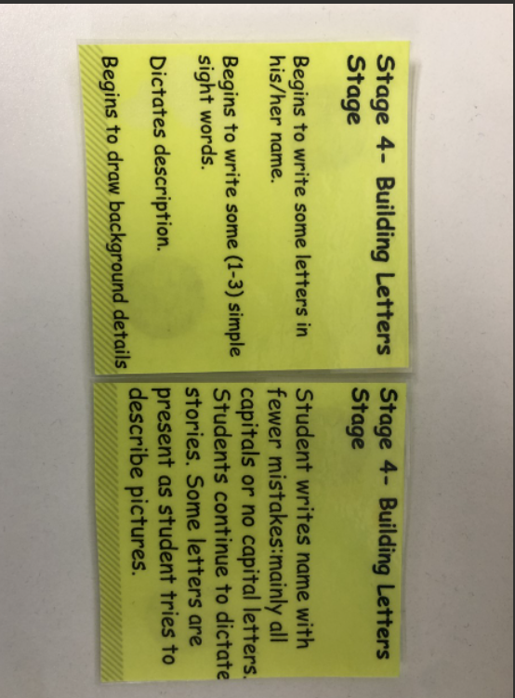
5 In phase 5, students write known words and new words they try to sound out. They also add more details to their picture. |  | 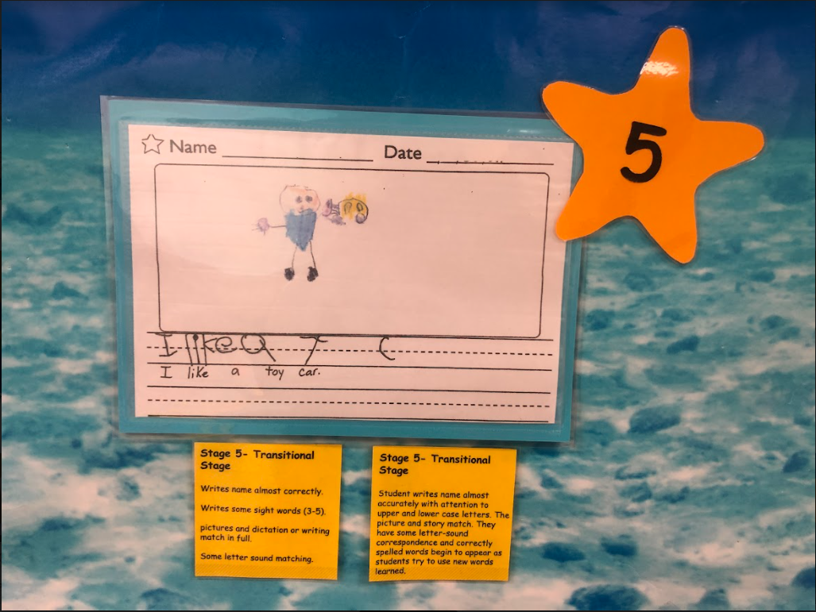 |  | 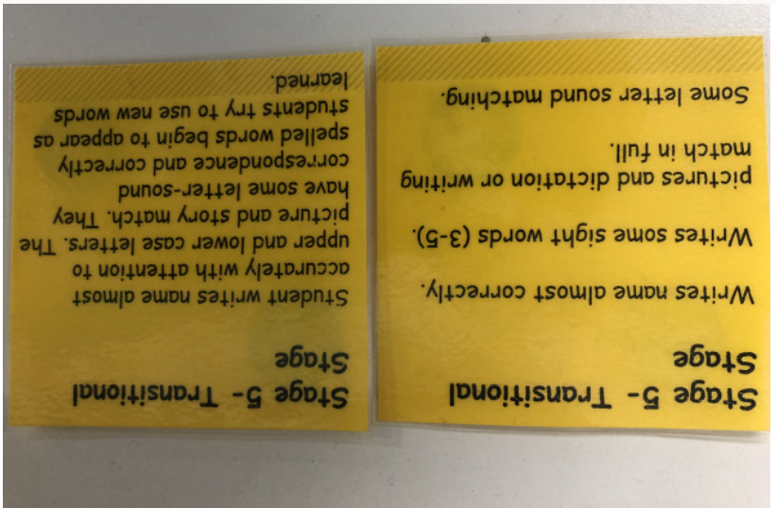

After the TK learners created this simple rubric with visual representations, we continued to work on another sight word writing piece. Once a student finished writing, we pulled the learners individually and asked them to score their writing using the writer’s checkpoint continuum. We documented what stage the student thought his/her work was currently and what they thought they needed to do to advance to the next stage. We placed the appropriate colored, pre-printed stage level post it note on their writing with their own words handwritten onto the note about where they were and where they thought they needed to go next.

Quality formative assessment practices help both the students and the teachers discover what comes next in the learning (Chappuis, 2012 and 2015; Erkens, Schimmer, and Dimich, 2017 and 2018; Wiliam, 2018; White, 2022). While the process of co-constructing a continuum for writing and conferencing with students certainly informed the students about what came next, it also informed us on where to head next. For example, we noticed while meeting with TK learners that the details in their pictures were lacking. We added an instructional activity to address the gap.

To teach TK learners to add details in their picture, we introduced a Directed Art activity. For this activity, we hand out a worksheet that has 4 different objects on the paper in different squares. For each object, we add details step by step as a class. If it’s a fish, we add water, bubbles, seaweed, etc. We are also beginning to use example videos (YouTube- Art hub for kids) that teach children how to draw pictures and add details “direct drawing.” Because this was powerful and effective, our plan going forward is to continue providing opportunities for TK learners to write using sight words and making sure the words written match the pictures they draw.

What did you notice?

The Impact on Student Writing

Free-flow journal: When we used the free-flow method of journaling, we found that our T.K TK learners struggle with knowing what to draw and how to draw it. Most just scribbled all over the page and called it something. Some TK learners got frustrated and started to ask teachers to draw for them or, worse, they simply gave up, which is far from ideal. At 4 years old, TK learners do not have a lot of life experiences to share, nor do they understand how to share them. Our ELLs (English Language Learners) really struggled with the concept of putting their thoughts down on paper. Some TK learners would cry and said writing was too hard for them. A few parents asked to hold off writing until after Christmas when they were older (TK learners are enrolled based on the criteria that they will turn 5 by Dec.2).

Directed journals: Directed Journaling worked much better than free flow journaling. When using a directed journal, TK learners seemed to be able to find an idea that related to the topic provided by the teacher.

Because they could relate to the topic, most TK learners were able to stay on topic and pick one thing from our brainstorming chart to draw a picture and write the word. Some TK learners would draw all kinds of pictures completely off topic. Others drew one picture and wrote different words just not the appropriate word to match the picture.

Shadow Writing: We noticed most of our TK learners became more confident while shadow writing. Although writing letters can be difficult at this age, students were less anxious knowing they had the sentence provided for them. It was clear that the anxiety of having to come up with or find words on their own to create a sentence was frustrating, especially for the handful of TK learners who are still struggling to hold a pencil due to a lack of fine motor control.

Sight word sentence writing: Sight word sentence writing worked well for those TK learners who could write or copy letters and/or words. It’s best if TK learners continue to work with this method to understand sentence structure and build fine motor skills. We have noticed TK learners who feel stressed while using this method will often ask for more paper to write more sentences.

Creating our class checkpoint: While working with writing in our class we had been struggling with the fact that we had no official TK rubric to help our TK learners understand what we were asking of them. We knew that our TK learners needed something visual to help guide their writing that followed our preschool foundations and beginning K standards. We previously had a rubric that followed Kindergarten standards but quickly realized that it was wordy and needed to be simplified. Plus, when using pre-developed rubrics, students were not part of the co-constructing criteria or identifying examples for each stage, so they were less accurate when self-assessing and less motivated to make a teacher directed improvement.

Adding details/Directed art: We found that using this strategy is one of the best things we have ever done with our TK learners because it clarified our expectations in tangible ways. We have always asked our students to fill in the blank for “what did you learn” sentence stems or advised our learners to “add details,” but, in either case, we were never as satisfied with the results. When one of our TK learners asked, “what are the details,” we realized the gap between our sage advice and their limited understanding. Students did not understand what we meant by “add more details.”

In the throes of our busy-ness with testing, grouping TK learners based on need, and engaging students in the more familiar activities like counting objects, it’s easy to forget that kids enter schools not knowing or understanding some concepts like “details.” Teaching them how to add details (using the “adding details worksheets”) to a picture has helped in their storytelling. In the past, when a student told the teacher she played with her friends over the weekend, it was typical that her pictures would include herself and 2 other people. Now, however, after direct instruction on what details look like, that same student is more likely to draw a bike or skateboard on the sidewalk, some trees and flowers, and maybe a playground. With details, the picture tells a complete story.

Likewise, when we realized our TK learners were struggling to draw, we decided to introduce them to Directed Art using “Art hub for Kid” on YouTube. This was an amazing discovery! Drawing along with this program (stopping as needed) has helped to boost many of the TK learners’ confidence in drawing skills and has removed some of their anxiety. We’ve also clarified that perfection is not required in the drawing and writing phases. This too has reduced much of their anxiety.

In this action research effort, we provided TO learners with visuals, a clear understanding of the various stages of writing, an opportunity to self-assess and set meaningful goals, and the opportunity to watch themselves move along the continuum of good writing. Through all of it, we have discovered that our TK learners take pride in the work they have produced. They strive to progress through the stages and improve their writing often. Neither students nor teachers are worried or encumbered in the writing process as we were in the past.

Visible Results

TK is not a tested year, and there are no hard numbers to prove that student writing improved using these processes. However, the resulting evidence was apparent to us and certainly worth noting for others.

The following examples highlight just a few of the many success stories we encountered over the course of our two-year effort. We can say with confidence that we answered our question how can we employ quality formative assessment practices that will improve student writing at the TK level?. Our formative practices did improve student writing at the TK level. We saw improvements in student clarity around quality of writing, consistency in overall writing improvements, and, more importantly, student enthusiasm for engaging in writing.

Figure 6: An example of a faster integration with clarity of expectation for a student who joined mid-year
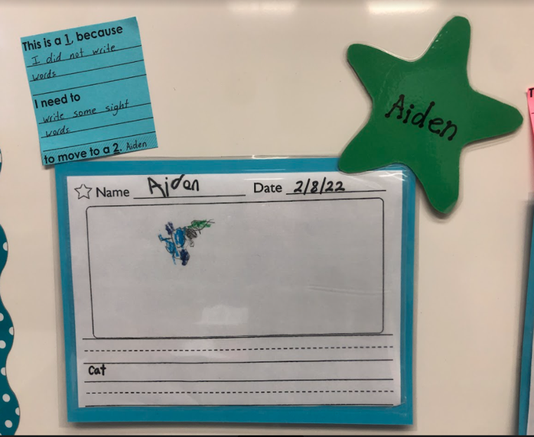
In this example, the student started in the classroom for the first time around January. The provided writing is from February. The student had done shadow writing a few times before but this was his first attempt at writing a sentence on his own. He was able to dictate one word but attempted to draw the cat he had described for dictation. When explaining what stage he thought he was at, he knew his paper was a level one by looking at the class checkpoint and telling the teacher that he needed to write words on his own to move up in stages. Seeing his peers write at higher levels and hearing their descriptions of quality writing as well as having a visual representation of what would be expected gave the student a feeling of excitement for his next opportunity to write. More importantly, he was able to move more quickly with his writing because the structure was in place and supported his growth.

Figure 6: An example of how confidence in teacher expectations can empower shy students to speak comfortably with teachers.

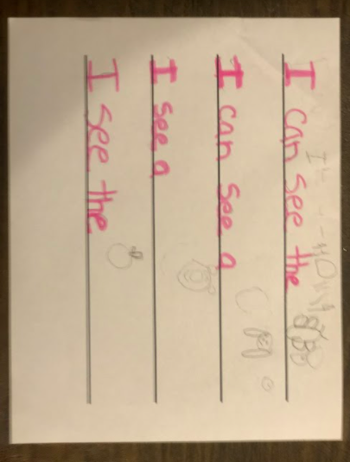 |  | 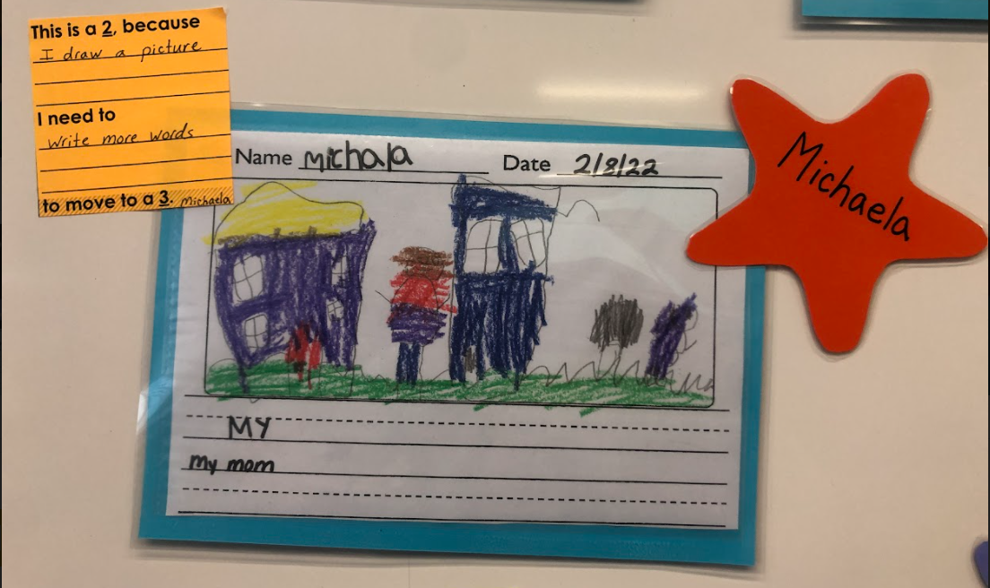
Picture 1 |  | Picture 2

Figure 6 is an example of a student being clear and able to express herself, even though she’s terribly shy. When she first arrived at school, she was very shy and struggled to express herself. When we first started doing any kind of writing she would just look at the teacher and shrug her shoulders rather than answer any questions. To improve her confidence, the teacher would use a highlighter to write the words that the student would then trace (picture 1). As she traced the teacher writing with repetition, she began to gain confidence and was able to write words that were not traced (as shown in picture 1). By February (picture 2) she was able to come up with her own idea to write about, express it to the teacher, write one of the words she recognized as a sight word, and then draw a picture that matched what she was trying to express. It was no small delight when the shy student was also able to let the teacher know she drew a picture to match what she thought, and then express her understanding that she needed to write more words to move to the next stage.

Figure 7: An example of how the process generated confidence in students with low confidence

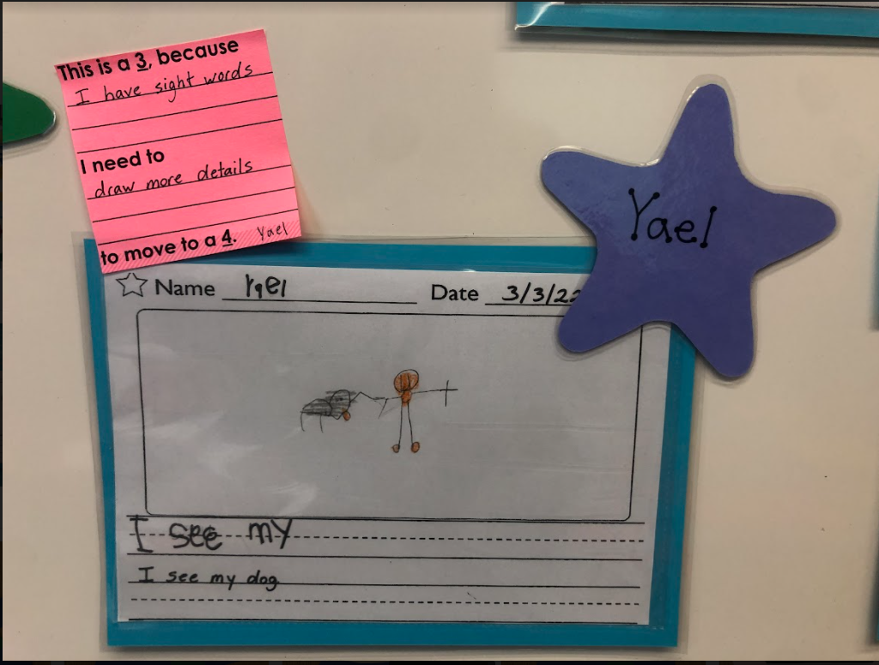
Picture 1 |  | Picture 2

The student sample in figure 7 was generated by a student who seemed to have a very low level of confidence or self esteem at the beginning of the year, especially when it came to writing. He would say he couldn’t do it and then proceed to cry throughout the entire writing lesson. But the formative writing process really helped him. Through the process of shadow writing, he began to gain confidence when he could produce something that was considered writing. He was very proud when he would finish shadow writing and he began drawing pictures on the back of his other work in class. He was also able to clearly and confidently describe his picture to the teacher. After a short time of shadow writing and free time drawing along with learning his sight words and how to use them to create a sentence, he was able to gain enough confidence to produce the beginning of a sentence on his own along with a picture to match it. While talking to him about his March sample of writing, he was able to explain that he used sight words to write a sentence. He also knew that in order to move to the next stage, he would need to draw some more details in his picture that could help clarify the setting, like a sun in the sky or grass below his feet.

Figure 8: An example of using targeted writing strategies to meet individual student needs

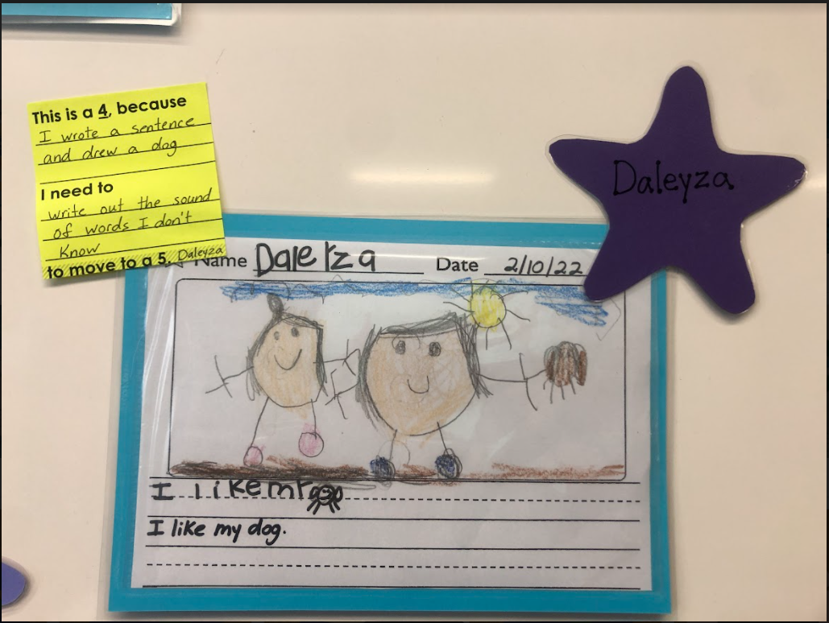 |  | 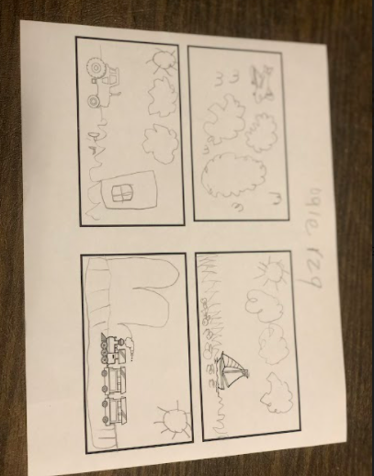
Picture 1 |  | Picture 2

The student sample provided in figure 8 was generated by a nervous student who was prone to shutting down completely when asked to engage in the writing process. She was already nervous when it came to shadow writing, but when the teacher prompted her to use her sight words to create a sentence or draw a picture to match it she would completely shut down. Because she was visibly nervous to put pencil to paper, the teacher used instructional scaffolds to provide concrete, manageable steps in the writing process. First, she was asked to use the direct drawing in a structured way as pictured above. Then, she learned to use shapes to draw. She began to create pictures. Daily, she engaged in singing along with the sight word songs. This seemed to help her, as she bagan using the sight words to form sentences. Putting the two together, she began to draw a picture in the sentence of the word she did not know how to write. By February she was able to write a sentence using sight words and then draw a picture of the word she did not know on her own as shown above. Moreover, she could clearly state that she was at stage 4 because she wrote a sentence and drew a dog which was the word she did not know. She stated that she knew that in order to get to stage 5, she would need to sound out that last word dog and attempt to write the letters that matched the sounds.

Figure 9: An example of how scaffolded supports helped with all parts of writing, including developing fine motor skills.

 |  | 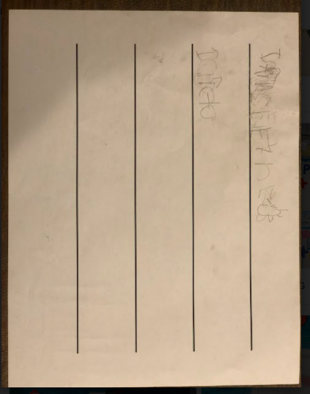 |  | 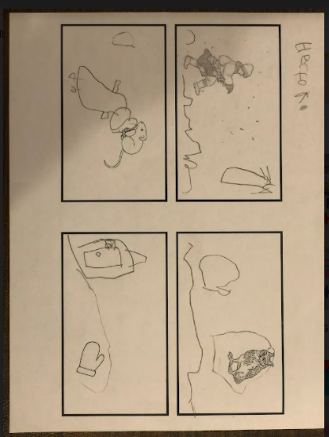
Picture 1 |  | Picture 2 |  | Picture 3
The student represented in figure 9 started the school year with excitement about writing and seemed to have much to say. He was excited to write. Sadly, he did not have the fine motor skills necessary to form letters. He struggled with shadow writing (as shown in picture 2 above) and drawing even the basic shapes at first. The smaller, chunkier golf pencil was a tremendous help to him. He practiced drawing the basic shapes and began to use those shapes to create pictures (as shown in the third picture above). He also began writing and building sentences with confidence. He was able to write the sight words he knew. He used the pocket chart lessons to help guide his writing. By February he was only writing a sentence with sight words and sounding out words he didn’t know, using the letter sounds he heard and recognized. While reviewing his writing with the teacher, he stated that he felt he was at a stage 5. He believed he was doing great work, but he thought he could add more details to his pictures.

Figure 10: An example of tremendous growth in short periods of time

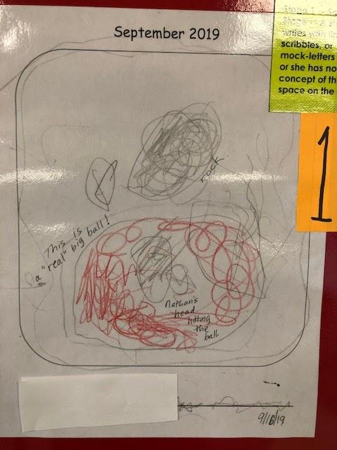 |  | 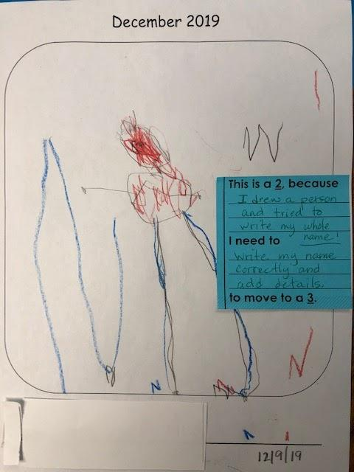
Picture 1 |  | Picture 2

The first picture in figure 10 was used as the exemplar for stage 1 writing. Early in the process, the student was only able to scribble, yet he could describe in his mind exactly what the image was without any distinguishing shapes or figures. Picture 2 above was only three months later. At that point the student was able to draw distinguishable shapes that looked like the item he was describing. He was so very excited that while conferencing with the teacher he ran to the rubric wall and excitedly explained that he had moved over a stage.

In every example from figure 6 to 10, students improved their confidence levels, improved their writing skills, and became excited about their individual growth. Their enthusiasm and interest in writing, led to more writing. Surprisingly, students requested more opportunities to tell their stories in writing.

What did you learn?

Insights for Others
It’s important to note that the action research project was interrupted by the pandemic. The students who entered the 21-22 school year were even further behind than the students who began the 19-20 school year.
]
- Because of the pandemic, we experienced a tremendous inconsistency in the attendance of our students. Even though students were supposed to come twice a week and zoom once a week, we seldom saw them with any consistency. Writing needs to happen often to be effective.
- TK students rarely come to school with the ability to write, so the pandemic did not change the beginning of the year’s writing process this year, except for fewer students being able to write their name.
- The 2021-22 TK students had less interaction with other students as well as other people they might have known throughout their community because their parents kept them safely at home due to the pandemic. As a result, the incoming class of students in the fall of 21 were immature and appeared to be more sheltered than the students from the 2019-2020 school year. They lacked social skills.

Pandemic or not, some key take aways remained consistent:

- We have learned that using the combination of the formative writing activities we structured provided pathways to support all of our learners – from the shy or nervous students to the excited student whose fine motor skills could not keep up with his desire to produce good work. Truly, our TK learners no longer fear writing; instead, they look forward to showing us how well they can write.
- We have decided not to start our school year with free flow journals any longer. Doing so was more frustrating for our TK learners, especially those who had trouble expressing themselves. They just weren’t ready for it, and we want them to love writing so much that they actually look forward to it without nervousness or concern.
- We have learned that our TK learners need a sequenced stream of formative, scaffolded activities to support their wide range of needs. Our selection and sequencing of activities can meet their various needs and eventually empower them be proud of their own work and their growth over time.
- We also have experienced an increase in enthusiasm for the writing process. Prior to our new protocol of formative assessments to scaffold our writers up to success, we would be just as stressed about having students write as they were about writing. We now look forward to watching our TK learners be involved and excited about writing.
- The Writer’s Checkpoint Continuum has truly illuminated the stages of growth, giving our TK learners the ability to be proud of their accomplishments and pushing them forward in their writing process.
- Using “Art Hub for kids” has been a great tool to help our TK learners work collaboratively while inspiring each other. Now they can see that another child their age can draw complicated pictures with ease and have fun doing it.
- We now know that with the right strategies, the right attitude, the right motivation, and the right level of excitement, TK children want to draw and tell their stories, a very important precursor to the exacting standards of writing in the K-12 system. At their young ages, it’s especially important to have a system outlined that can carefully guide them to success and help them overcome the popular fear of mistakes that paralyzes many student writers.

What recommendations do you have for other teachers?
- Start small when introducing writing to young kids.
- Allow them to describe what they see, being careful to use their wording. This is an important step before asking them to produce something you describe.
- Be patient and try everything until you find what works for you.
- Alter your formative processes as needed so that you can target each individual student’s needs.

What will you try next because of this new writing process?
- Moving forward, we plan to add another directed learning experience (somewhere near the use of directed journals) similar to the Adding Details Directed Art. In this new addition, students would use shapes to create simple pictures. Our goal would be to build on prior knowledge by incorporating known shapes (like sight words) as students draw simple pictures using only the basic shapes they have learned. Because they will have already had extensive practice with these shapes, we anticipate the directed draw piece will be less stressful, and learners will feel more successful once they see they can draw a picture with ease.
- We are working on changing our stages of writing within the Writer’s Checkpoint Continuum to be a more visual rubric (giving our TK learners more visual support) rather than simple words we currently use.
- Toward the end of the year, we are going to try having TK learners use the directed art format page to create scenes of their own. We will also have them dictate to us what they decided to draw.

This action research plan taught us that with enough planning and follow through, a well-developed writing process can help young students (ages 4-5) grow to feel self-confident in themselves as artists, story tellers, and eventually authors when it comes to beginning writing. The steps listed above are easy to follow and the students enjoy the time spent learning, whether it’s time spent drawing an object or person, or telling their story in their own words. Our students enjoy the freedom they find in drawing and writing about the things they find most meaningful or interesting.

We learned much as we answered our question, can we employ quality formative assessment practices that will improve student writing at the TK level? Even through much change or chaos, our findings were worth the effort we invested. We loved seeing their enthusiasm and pride improve over time. We are thrilled that our efforts are producing confident, capable writers.

References

Chappuis, J. (2012). “How am I doing?” Educational Leadership, 70(1), 36–40.
Chappuis, J. (2015). Seven strategies of assessment for learning (2nd ed.). Portland, OR: Pearson Assessment Trainers Institute.
Data Quest (ND). California Department of Education. https://dq.cde.ca.gov/dataquest/page2.asp?Level=School&Subject=Enrollment
Erkens, C., Schimmer, T., & Dimich, N. (2017). Essential assessment: Six tenets for bringing hope, efficacy, and achievement to the classroom. Bloomington, IN. Solution Tree Press.
Erkens, C., Schimmer, T., & Dimich, N. (2018). Instructional agility: Responding to assessment with real-time decisions. Bloomington, IN. Solution Tree Press.
Wiliam, D. (2018). Embedded formative assessment, 2nd, ed. Bloomington, IN: Solution Tree Press.
White, K. (2022). Self-assessment: Data notebooks, portfolios, & other tools to advance learning. Bloomington, IN: Solution Tree Press.

